GETTING FATTER TO LIVE LONGER: THE RELATIONSHIP BETWEEN DIAPAUSE THE DIAPAUSE LENGTH AMONG EUROPEAN CORN BORERS, *Ostrinia nubilalis* (LEPIDOPTERA: CRAMBIDAE)

By

JAMES T. BROWN

A THESIS PRESENTED TO THE GRADUATE SCHOOL

OF THE UNIVERSITY OF FLORIDA IN PARTIAL FULFILLMENT

OF THE REQUIREMENTS FOR THE DEGREE OF MASTER OF SCIENCE

UNIVERSITY OF FLORIDA

2019

 2019 James T. Brown

To my family

ACKNOWLEDGMENTS

I thank my major adviser Dr. Daniel Hahn for supporting my research and professional development, and I thank my committee members Dr. John Beck and Dr. Robert Meagher for their pragmatism and unique perspectives. I also thank Dr. Qinwen Xia-Chen, Dr. Chao

Chen, Nausheena Baig, and Dr. Caitlin Rering for their assistance with experimental design,

Dr. Andrew Nguyen for his assistance with data analysis, and Dr. Charles Stuhl, Dr. Leigh Boardman, Clancy Short, and Dylan Tussey for stimulating my intellect and inspiring ideas. I also thank the Entomology and Nematology Department of the University of Florida and the

United States Department of Agriculture, Agricultural Research Services, Center for Medical, Agricultural, and Veterinary Entomology (USDA-ARS CMAVE) for supporting me financially during my degree program. Finally, I thank every student in the Entomology and Nematology

Student Organization for their friendship and support.

TABLE OF CONTENTS

ACKNOWLEDGMENTS . . . . . . . . . . . . . . . . . . . . . . . . . . . . . . . . . . . 4

LIST OF TABLES . . . . . . . . . . . . . . . . . . . . . . . . . . . . . . . . . . . . . . 6

LIST OF FIGURES . . . . . . . . . . . . . . . . . . . . . . . . . . . . . . . . . . . . . 7

ABSTRACT . . . . . . . . . . . . . . . . . . . . . . . . . . . . . . . . . . . . . . . . . 8

CHAPTER

1. INTRODUCTION . . . . . . . . . . . . . . . . . . . . . . . . . . . . . . . . . . . 9
2. THE EUROPEAN CORN BORER, *Ostrinia nubilalis* (LEPIDOPTERA: CRAMBIDAE) 13
   1. Phylogeny of *Ostrinia nubilalis* . . . . . . . . . . . . . . . . . . . . . . . . . 14
   2. Life History of *Ostrinia nubilalis* . . . . . . . . . . . . . . . . . . . . . . . . . 17
3. EUROPEAN CORN BORER: THE RELATIONSHIP BETWEEN STORED RESOURCES AND DIAPAUSE TIMING . . . . . . . . . . . . . . . . . . . . . . . . . . . . . . . 21
   1. Background . . . . . . . . . . . . . . . . . . . . . . . . . . . . . . . . . . . 21
   2. Methods . . . . . . . . . . . . . . . . . . . . . . . . . . . . . . . . . . . . . 22
      1. General Rearing . . . . . . . . . . . . . . . . . . . . . . . . . . . . . . 22
      2. Experiment 1: Estimating the Onset Diapause and Classifying Diapause-Programmed Larvae Using Metabolic Activity . . . . . . . . . . . . . . 23
      3. Experiment 2: The Onset of Wandering and Measuring Stored Lipids 25
      4. Statistical Analyses . . . . . . . . . . . . . . . . . . . . . . . . . . . . 27
      5. Results . . . . . . . . . . . . . . . . . . . . . . . . . . . . . . . . . . . . . . 28
      6. Experiment 1: Metabolic Activity . . . . . . . . . . . . . . . . . . . . 28
      7. Experiment 2: Stored Lipids . . . . . . . . . . . . . . . . . . . . . . . 30
   3. Discussion and Conclusions . . . . . . . . . . . . . . . . . . . . . . . . . . . 31

LIST OF REFERENCES . . . . . . . . . . . . . . . . . . . . . . . . . . . . . . . . . . . 51

BIOGRAPHICAL SKETCH . . . . . . . . . . . . . . . . . . . . . . . . . . . . . . . . . 56

LIST OF TABLES

# Table

2-1 Subgroups of *Ostrinia* uncus group III using mid-tibiae length . . . . . . . . . . . . 19

3-1 Comparing CO2 production between individuals reared in diapause programming

and non-diapause conditions. . . . . . . . . . . . . . . . . . . . . . . . . . . . . . 46

3-2 Model selection by factor elimination for lean mass accumulation prior to the onset

of diapause . . . . . . . . . . . . . . . . . . . . . . . . . . . . . . . . . . . . . . . 47

3-3 Linear mixed effect model comparison of lean mass accumulation between diapause

genotypes before the onset of diapause . . . . . . . . . . . . . . . . . . . . . . . . 47

3-4 Model selection by factor elimination for lipid mass accumulation prior to the onset

of diapause . . . . . . . . . . . . . . . . . . . . . . . . . . . . . . . . . . . . . . . 48

3-5 Linear mixed effects model comparison of lipid mass accumulation between genotypes

before the onset of diapause . . . . . . . . . . . . . . . . . . . . . . . . . . . . . . 48

3-6 Model selection by factor elimination for lean mass depletion during diapause . . . . 49

3-7 Comparing lean mass depletion between diapause genotypes during diapause . . . . 49

3-8 Model selection by factor elimination for lipid mass depletion during diapause . . . . 50

3-9 Comparing lipid mass depletion between diapause genotypes during diapause . . . . 50

LIST OF FIGURES

# Figure

|  |  |
| --- | --- |
| 1-1 Predictive the relationship between nutrition stores and diapause genotype. . . . . . | 12 |
| 2-1 Chemical structure of sex pheromone components . . . . . . . . . . . . . . . . . . | 20 |
| 3-1 Observations of larvae in diapause programming conditions . . . . . . . . . . . . . | 37 |
| 3-2 Wandering assay tray . . . . . . . . . . . . . . . . . . . . . . . . . . . . . . . . . | 38 |
| 3-3 Distribution of larvae entering the wandering stage . . . . . . . . . . . . . . . . . .  3-4 Accumulation of wet mass among larvae in diapause programming and non-diapause | 39 |
| conditions. . . . . . . . . . . . . . . . . . . . . . . . . . . . . . . . . . . . . . . .  3-5 Comparing CO2 production between larvae with different diapause genotypes when | 40 |
| reared under the same photoperiod . . . . . . . . . . . . . . . . . . . . . . . . . .  3-6 Comparing CO2 production between larvae with the same diapause genotype when | 41 |
| reared in different photoperiods . . . . . . . . . . . . . . . . . . . . . . . . . . . .  3-7 Comparing wet mass accumulation and CO2 production between shallow-diapause | 42 |
| and deep-diapause larvae with the short-diapause genotype . . . . . . . . . . . . .  3-8 The effect of diapause programming on lean mass and lipid mass accumulation prior | 43 |
| to the onset of diapause . . . . . . . . . . . . . . . . . . . . . . . . . . . . . . . .  3-9 The effect of diapause programming on lean mass and lipid mass depletion during | 44 |
| diapause . . . . . . . . . . . . . . . . . . . . . . . . . . . . . . . . . . . . . . . . | 45 |

Abstract of Thesis Presented to the Graduate School of the University of Florida in Partial Fulfillment of the Requirements for the Degree of Master of Science

SEASONAL CUES AND DIAPAUSE PREPARATION IN THE EUROPEAN CORN BORER, *Ostrinia nubilalis* (LEPIDOPTERA: CRAMBIDAE)

By

James T. Brown

May 2019

Chair: Daniel A. Hahn

Major: Entomology and Nematology

Diapause is a genetically determined life history strategy commonly used by many insects in temperate regions to avoid the consequences associated with low winter temperatures. Because food is scarce during winter, insects conserve energy by decreasing metabolic activity and suspending development. To meet the energy demands of their suppressed metabolism during diapause, insects often accumulate greater energy reserves before the onset of winter. Moreover, after diapause ends, some insects rely on that same pool of stored energy to complete metamorphosis, find mates, and reproduce. Climate change is predicted to impact diapausing insects as warmer and more variable winter temperatures increase metabolic activity, possibly reducing energy stores. How temperate-insects manage nutrition in preparation for diapause and during diapause in response to climate change could be crucial in determining which insects will survive warmer temperatures. Using two strains of *Ostrinia nubilalis* (Hubüner) reared in conditions that induce diapause and measuring lipid storage, my goal was to determine the degree to which different diapause genotypes (long-diapause and short-diapause) affect nutrition accumulation in preparation for diapause and nutrition depletion during diapause. European corn borers of both genotypes increased lipid stores when programmed for diapause, and lipid stores among diapause-programmed larvae were higher among larvae with the long-diapause genotype compared to the strain with the short-diapause genotype. However, I did not detect a difference in lipid depletion during diapause between the long-diapause and short-diapause genotypes. Reducing lipid stores before the onset of diapause could limit energy available to fuel metabolic activity during diapause and could be one way to manage *O. nubilalis* pest populations. Before using the diapause genotype as a tool to predict pest population responses to climate change, more research must be done to better understand the relationship between nutrient management, diapause length, and overwintering survival.

CHAPTER 1

INTRODUCTION

In temperate regions, seasons cycle predictably between warm spring and summer periods and cool fall and winter periods. Temperature variation has a strong influence on the growth and performance of animals, and it fluctuates daily, seasonally, and from year to year. During the warm and humid seasons when conditions are favorable resources like food and water are available for animal growth, development, and reproduction. As seasons cycle from summer to winter, conditions become cold, dry, and unfavorable as these conditions reduce metabolic activity and make continued activity challenging or even impossible for many insects. To protect themselves from unfavorable seasonal changes, many animals synchronize their life history with their environment by monitoring biotic and abiotic cues in their environment that consistently cycle with seasonal change. The ability to reliably predict seasonal changes and avoid unfavorable temperatures is probably one of the most important challenges all organisms encounter. Many temperate-living insects have evolved seasonal dormancy (diapause) as a strategy to protect themselves from unfavorable seasons. Climate change could disrupt the life history synchrony as seasonal predictability decreases and seasonal temperatures increase, disrupting the predictability insects use to synchronize their life histories with their environment, and threatening the survival of some insects.

According to the National Oceanic and Atmospheric Administration, 2016 was the warmest year on record with global surface temperatures and North American land surface temperatures averaging 0.94 °C and 1.86 °C above the 20th century averages, respectively (NOAA National Centers for Environmental Information 2017). Conservative projections of future temperatures estimate at least a 1.5 °C increase in global surface temperature by the end of the 21st century with temperatures continuing to increase thereafter (DeLucia et al. 2008, Stocker et al. 2015). Seasonal temperature averages in the United States during 2016 echoed this upward trend for all four seasons surpassing all previously recorded temperature averages (NOAA National Centers for Environmental Information 2017). Warmer temperatures will effectively increase the duration of the warm growing season as fall, winter, and spring temperatures increase (Bradshaw and Holzapfel 2006, Hahn and Denlinger 2011, Scriber 2014). As insects continue to experience the effects of climate change, warmer temperatures could affect the performance, population range and density, and/or life history timing of insects as they adjust to increased seasonal variation. Generally, the metabolic rates exhibited by ectothermic species correspond to the environmental temperatures they experience (Nespolo 2003). Higher temperatures increase metabolic rates and lower temperatures reduce metabolic rates. Increased growing season temperatures for ectothermic insects could affect their performance by increasing their metabolic rates, speeding up their growth, and possibly shortening the development time to reproductive maturity (Nespolo 2003). Mature adults that occur earlier in the growing season could increase the number of generations each year (Bale et al. 2002, Bradshaw and Holzapfel 2006, Hahn and Denlinger 2011, Scriber 2014).

The performance of insects is influenced by the thermal conditions they experience in their environments and increased temperatures could be either positive or negative (Huey and Stevenson 1979, Chown 2007). As climate changes, insects whose populations are impacted negatively by those changes can be colloquially termed “losers” and those impacted positively can be termed “winners”. The direct and indirect interactions between temperature and the resulting winners could lead to expanded geographic ranges, increased population size, or increased temperature tolerance (Hughes 2000, Williams et al. 2008). An insect’s body temperature directly affects its performance, and the effect of body temperature on performance can be described using a thermal performance curve (Huey and Stevenson 1979). At the peak of this curve is an insect’s thermal optimum, which is the temperature where performance is maximized (Huey and Stevenson 1979). The range of temperatures where the performance of an insect is half of the thermal optimum represents the thermal breadth (Huey and Stevenson 1979). Finally, the range of temperatures within which any performance is permitted is an insect’s thermal tolerance range (Huey and Stevenson 1979). Temperatures at the edge of an insects thermal tolerance are termed the critical thermal maximum and critical thermal minimum, respectively (Bale et al. 2002, Huey et al. 2012, Sinclair et al. 2016).

Warmer temperatures for losers could directly reduce their performance by exceeding their thermal breadth. Continued temperature increases for these losing insects could exceed their thermal maximum and eventually cause mortality. Winners in contrast could have wider thermal breadths and tolerate warmer temperatures. Winners, whose thermal environment is currently below their thermal optimum, could experience increased performance as temperatures increase towards their thermal optimum. In a review of the effects of thermal conditions on population fitness (with fitness defined as the intrinsic population growth of r-strategy insects), Deutsch et al. (2008) tracked and compared population size between 38 representative insect species from temperate and tropical latitudes. For those representative species across temperate latitudes, the thermal breadth of these insects tended to be wider and the thermal conditions experienced in these locations, on average, tended to be further away from their critical thermal maximum compared to the representative taxa from tropical latitudes (Deutsch et al. 2008). In the tropics, environmental temperatures vary little relative to temperatures in temperate regions and insects in tropical regions experience temperatures that tend to be closer to their optimum temperature relative to temperate insects whose environment tends to be cooler than optimum. This suggests that tropical insects already live near their thermal limits and thus could quickly become losers as climate warms.

Warmer days arriving earlier in the spring and ending later in the fall will extend the duration of the warm growing season in temperate regions. In effect, the seasonal temperatures experienced in northern latitudes will resemble the seasonal temperatures of the adjacent southern latitudes, increasing the geographic distribution of warmer environments (Parmesan et al. 1999, Breed et al. 2012). Winners could experience a net increase in both population size and geographical range with more individuals spread across more geography. Winners could also experience a northern shift of their entire geographical range with no change in population size (Parmesan et al. 1999). In Europe, changes in ranges have been observed in 35 species of non-migratory butterfly species (Parmesan et al. 1999). Of these butterflies, 63% were observed to have a distribution shift northward and 3% were observed to have a distribution shift southward (Parmesan et al. 1999). As favorable thermal conditions for winning insects shift farther north and warmer days increase in frequency and duration, the spatial distribution of winning insects could track those favorable temperatures. Insects that are unable to shift their geographic range of their population or unable to tolerate increasing temperatures in their current environment could experience shrinking southern distributions, smaller population sizes and lose as climate changes.

While warming northern latitudes do offer climate change winners the opportunity to shift their population distributions and ranges, those insects that experience range shifts will be exposed to environmental cues, like photoperiod, that are intrinsic to the latitudes where these shifts occur. Photoperiod, like temperature, is an important environmental cue that insects use to make life history decisions (Bale et al. 2002). Photoperiod changes incrementally by latitude and season (Hut et al. 2013). During the summer, photoperiod is long and increases as latitude increases; while in the winter, photoperiod is short and decreases as latitude increases. Insects actively work to avoid conditions that become too stressful and take advantage of conditions that are favorable by monitoring both their internal condition as well as the external environment and responding to changes in those environments as they occur, ensuring their survival. Many insects in temperate regions use the consistent, incremental changes in photoperiod at specific latitudes to synchronize their life histories with the availability of resources in their environment and avoid stress (Bale et al. 2002). Failure to adjust to the photoperiods of these warmer northern latitudes could negatively impact the timing of life history events for those shifted populations, turning winners into losers.

As temperatures rise, winning insects could express phenotypic plasticity or experience evolutionary adaptations in their dormancy strategy to adjust to the shifting landscape of seasonally stressful environmental conditions. Phenotypic plasticity is defined as the capacity of a single genotype to express multiple, different phenotypes as a function of the environmental conditions that the genotype encounters (Agrawal 2001). Evolutionary adaptations are genetic changes that occur within populations due to selection (Lee 2002). Environmental stress that occurs over a relatively short period of time can be categorized as acute stress, while stress that occurs over a relatively prolonged period can be considered chronically stressful. Stress in an insect’s natural environment could be any condition that, if encountered, impacts growth, reproduction, or survival. Common environmental stresses for insects include extreme temperatures, ice, desiccation, and reductions in the availability of food. In general, dormancy is a state of metabolic and developmental suppression many insects use to mitigate the effects of both acute and chronic seasonal stress they encounter in their environment (Koštál 2006).

As insects monitor their environment and perceive acute environmental stress, some use quiescence to quickly respond to these relatively short-term conditions. Quiescence is a transient state of reduced activity that insects can use to temporarily protect themselves from environmental stress (Koštál 2006). Once the stress is relieved (provided the exposure was not too extensive), quiescence is reversed, and the insect’s activity can resume after some period of recovery. Seasonal temperature change is a common long-term stress that insects encounter in their environment. To avoid or mitigate the consequences of predictable seasonal environmental stress during the winter, many insects use diapause (Hahn and Denlinger 2011, Koštál 2006). For most temperate insects, maintaining a suitable metabolic rate for continued development becomes challenging in the winter when temperatures fall too low. Further, as resource availability declines, they struggle to acquire enough energy to fuel metabolism, growth, and development (Denlinger 2002, Hahn and Denlinger 2007). Diapause is one way that insects can protect themselves from predictable and chronic winter stress. However, unlike quiescence, diapause is generally induced well before their environment degrades and becomes stressful (Hahn and Denlinger 2011, Denlinger 2002). Diapause is a genetically regulated, environmentally influenced alternative developmental trajectory that is usually marked by feeding cessation, metabolic suppression, and arrested development (Denlinger 2002, Koštál 2006). By monitoring environmentally consistent cues like photoperiod that cycle with seasonality, insects can reliably predict, prepare for, and protect themselves from seasonal changes in temperature by inducing diapause (Denlinger 2002, (Koštál 2006).

Within a single insect species, the environmental cues that stimulate diapause, the life stages sensitive to those cues, and the resulting diapause phenotype are generally consistent and under genetic control (Bale and Hayward 2010). The developmental stage when diapause occurs can vary from species to species or can even vary among populations within a species (Denlinger 2002). Variation in diapause life stage aside, the diapause developmental trajectory always has three sequential stages: pre-diapause (or induction), diapause, and post-diapause (Denlinger 2002, Koštál 2006). Before diapause can be induced, an individual must reach a genetically determined sensitive period. Sensitive insects can perceive the environmental cue or cues that induce diapause, and during this period they are physiologically competent to respond to that cue or cues (Denlinger 2002, Koštál 2006). During pre-diapause, the sensitive stage perceives the necessary environmental cue or cues, diapause is induced, and there is a shift away from continuous development and towards the diapause developmental trajectory (Denlinger 2002, Koštál 2006).

Generally, diapause is induced before an insect experiences seasonal changes in their environment. Preemptive induction of diapause provides insects the opportunity to accumulate and store resources needed to survive diapause before seasons change (Koštál 2006). During pre-diapause many insects prepare for diapause by accumulating and storing resources in the form of lipids, proteins, and carbohydrates to be used as fuel during diapause (Hahn and Denlinger 2011). Because most insects do not feed during diapause, it is imperative that insects accumulate enough resources to meet the energetic demands of the long diapause period (Hahn and Denlinger 2011). Furthermore, after diapause ends insects must have enough stored resources remaining to meet the anabolic requirements for development, metamorphosis, repair, and post-diapause activities like reproduction (Hahn and Denlinger 2007, Sinclair 2015).

Diapause initiation is generally marked by the suspension of continuous development and a reduction in metabolic activity (Tauber and Tauber 1981, Koštál 2006, Hahn and Denlinger 2007, Sinclair 2015). During diapause maintenance, the endogenous mechanisms that support the diapause phenotype persist and diapausing insects must continue to meet the energetic demands of their metabolism during diapause (Koštál 2006, Hahn and Denlinger 2007). Diapause termination is marked by the release of those endogenous factors that initiate and maintain diapause, allowing development to resume under permissive conditions (Koštál 2006). After diapause is terminated, the potential to resume development exists. However, many insects do not immediately resume development. Instead, under non-permissive conditions, post-diapause insects remain quiescent and their development is arrested by exogenous environmental factors like low temperatures (Koštál 2006, Denlinger 2002). When the exogenous factors permissive to growth become available, development can resume (Koštál 2006, Denlinger 2002). The timing of diapause initiation is crucial because developmental arrest and metabolic suppression can produce profound behavioral and physiological changes (Koštál 2006, Denlinger 2002). If an insect enters diapause too late they could expose themselves to stressful environmental conditions and if diapause ends too soon the environment may not be suitable for that insect’s growth and development, or mates may not be available for reproduction.

As climate changes and average seasonal temperatures increase, the duration of the warm growing season is expected to increase. With growing seasons beginning earlier and ending later, some of the seasonal cues that insects use to predict changes in their environment, like photoperiod, will not change (Bradshaw and Holzapfel 2008). In time, the predictions of those unchanged environmental cues will become decoupled from actual seasonal changes as growing seasons become longer and winter shrinks. Environmental cues that previously signaled the end of the growing season will underestimate the end of the longer growing season (Bradshaw and Holzapfel 2008). Hypothetically, a photoperiod of 13 hours that historically indicated the average beginning of the growing season in the future could indicate on average the second week of the growing season as climate changes and temperature increases. Warmer seasonal temperatures will uncouple photoperiod from seasonal changes in temperature and resource availability. Insects that depend on photoperiod to make life history decisions but cannot adjust to the warmer temperatures approximated by photoperiod, could lose. Those insects that adjust to these underestimated predictions and resynchronize their lifecycles with the growing season, either by evolutionary adaptations or phenotypic plasticity in their response to these shifting environmental cues, could win as climate changes.

The pitcher plant mosquito provides one example of how insects could adjust to longer and warmer growing seasons through evolutionary adaptation. Bradshaw and Holzapfel (2001) showed that populations of the pitcher plant mosquito, *Wyeomyia smithii* (Coquillett), have shifted their critical photoperiods for diapause induction to extend their growing season, consistent with predictions for climate change.Critical photoperiod is the number of light hours required to induce diapause in 50% of a population. In *W. smithii* the critical photoperiod for diapause induction is highly heritable Bradshaw and Holzapfel (2001). As larvae, pitcher plant mosquitoes grow and develop in the water-filled leaves of pitcher plants. These mosquitoes inhabit temperate regions as far south as the Gulf of Mexico and as far north as northern Canada (Bradshaw and Holzapfel 2001). Across this wide latitudinal range, pitcher plant mosquitoes experience their longest growing seasons at the southern end of their range and increasingly shorter growing seasons at more northern latitudes (Bradshaw and Holzapfel 2001). At the end of the warm growing season, photoperiod gets shorter. Once photoperiod drops below a genetically determined number of light hours, larvae perceive that cue and enter the larval diapause developmental trajectory.

Bradshaw and Holzapfel (2001) sampled several populations of *W. smithii* larvae from latitudes between Florida and Canada in the years 1972, 1988, 1993, and 1996 and reared them in a common-garden laboratory setting under strict environmental control. Populations collected in 1972 and 1996 were exposed to a range of different photoperiods to determine their critical photoperiod (Bradshaw and Holzapfel 2001). In 1972, the critical photoperiod of larval populations collected at 50 °N, averaged 15.79 hours while the critical photoperiod of larval populations collected in 1996 at the same latitude averaged 15.19 hours (Bradshaw and Holzapfel 2001).

Because of the rigor with which these experiments were conducted and the highly heritable nature of critical photoperiod within this species, these results suggest the populations collected in 1996 have evolved and are now genetically different than populations collected in 1972 (Bradshaw and Holzapfel 2001). Northern pitcher plant mosquitoes, on average, are delaying diapause by approximately 9 days and this shift correlates with the average increase in the number of warmer days experienced in this region (Bale and Hayward 2010). Delayed diapause initiation could be evolutionarily adaptive. For pitcher plant mosquitoes, warmer temperatures are indirectly responsible for the increased availability of environmental resources these mosquitoes need to grow and develop. The mosquitoes that delay diapause initiation could access those resources and continue to grow, develop, and reproduce for an additional 9 days. For some insects, warmer seasonal temperatures and longer growing seasons will increase the duration of resource availability. Insects that can adjust to longer growing seasons without compromising the protection of diapause could be winners as climates change.

Climate change can lead to disruptions in diapause-mediated life history synchrony between insects and their environments as seasons become less predictable. If diapause begins before the favorable season ends it could limit an insect’s ability to take advantage of available resources. Early entry into diapause could also lead to the premature depletion of stored nutrients as metabolic activity during diapause relies on stored energy. If the onset of diapause is late and occurs after the unfavorable season begins an insect could be exposed to conditions that could cause mortality. Genetic variation in diapause-associated life history traits within and among species similar to those shown in the pitcher plant mosquito could serve to resynchronize insect life histories by the evolution of diapause through natural selection as climate changes and seasonality becomes less predictable.

During diapause, temperatures are low and metabolic activity may be suppressed. However, insects can metabolize considerable quantities of nutrients during this period. In preparation for diapause, some insects accumulate large quantities of lipids, amino acids, and/or carbohydrates (Denlinger 2002, Hahn and Denlinger 2011). For some insects, the nutrients accumulated prior to diapause initiation must also be utilized for metamorphosis or to supplement a restricted diet once diapause is terminated (Hahn and Denlinger 2007). Lipids, specifically triglycerides, are the predominant source of metabolic energy used during diapause in most species (Arrese and Soulages 2010, Hahn and Denlinger 2011). Triglycerides can be accumulated directly from an insect’s diet or synthesized in the fat body from amino acids or carbohydrate intermediates (Hahn and Denlinger 2007, Arrese and Soulages 2010). Amino acids are generally stored as multimeric hexamerin proteins (Denlinger 2002). Hexamerins are specialized protein complexes that build up in the insect fat body or hemolymph prior to diapause and function as amino acid reservoirs (Burmester and Scheller 1999). During diapause, as metabolic proteins accumulate damage or are destroyed, the amino acids in hexamerins could be mobilized and used to repair or replace damaged proteins (Burmester 1999, Hahn and Denlinger 2007). After diapause, hexamerin proteins could be catabolized and the constituent amino acids can be used to build exoskeleton, repair damaged proteins, and build new tissues during morphogenesis (Burmester 1999, Hahn and Denlinger 2007). Carbohydrates are polymerized and stored as glycogen in the fat body or as trehalose in the hemolymph (Hahn and Denlinger 2007, Arrese and Soulages 2010).

Preparations for prolonged low temperatures and the absence of environmental resources requires some insects to accumulate and store proportionally more lipids than carbohydrates or proteins to fuel their metabolism. For example, diapausing female *Culex pipens* L.mosquitoes reared at 22 °C and under a 9-hour photoperiod accumulate significantly more lipids in preparation for diapause relative to their non-diapausing conspecifics reared at the same temperature and under a 14-hour photoperiod (Mitchell and Briegel 1989). These stored lipids are utilized as a source of energy during diapause (Mitchell and Briegel 1989). In other insects, diapause preparation has been shown to lead to an increase in hexamerin storage, as observed in the Colorado potato beetle, (*Leptinotarsa decimlineata* (Say)). When Colorado potato beetles were laboratory reared under two different photoperiods, a 10-hour photoperiod to induce diapause and an 18-hour photoperiod to bypass diapause, diapause-programmed beetles had substantially higher transcript abundance of the hexamerin diapause protein 1 (De Kort and Koopmanschap 1994).

As climate changes, warm summers will begin earlier and end later followed by shorter and warmer winters. Increasing temperatures will generally increase metabolic activity in insects, including dormant insects, and increased metabolic activity will require more nutrients to fuel metabolism. Nutrients accumulated by insects in preparation for diapause at the end of the growing season, and used during diapause, could be affected by increased metabolism due to increased environmental temperatures. These changes could potentially affect both survival through diapause and/or post-diapause performance. In preparation for diapause, climate change losers could be unable to accumulate or store enough nutrients possibly resulting in an energy deficit at the beginning of diapause. During diapause, losers encountering increased temperatures could deplete their reservoirs of stored nutrients to meet their increased metabolic demands before diapause ends and not survive the winter. Insects able to accumulate more nutrients during pre-diapause or properly allocate stored resources to support their increased metabolism during diapause could be winners as climate changes. I predicted that the quantity of nutrition stored by European corn borers in preparation for the additional stress of diapause will be associated with the differences in diapause length between the two strains. European corn borers preparing for a longer or a warmer diapause period will accumulate more nutrition during diapause preparation compared to larvae preparing for a shorter diapause period or continuously developing larvae (Figure 1-1A). Additionally, I predict the rate of nutrition depletion during diapause will be the same between for all European corn borers, regardless of diapause length (Figure 1-1B). Quantifying the metabolic demand for nutrient storage in preparation for diapause and nutrition depletion during diapause as a function of diapause length could provide a way to predict climate change winners and losers as growing seasons increase in duration.

The effects of anthropogenic climate change will lead to longer growing seasons and as poleward regions will become warmer more geography will be thermally favorable to winners, thus both the geographic range and voltinism at each point in the range may be increased. Research into the relationship between diapause phenology, nutrition management in preparation for diapause, and how insect pests could respond to changing climate may provide possible targets for future pest management.

CHAPTER 2

THE EUROPEAN CORN BORER, *Ostrinia nubilalis* (LEPIDOPTERA: CRAMBIDAE)

2.1 Phylogeny of *Ostrinia*

The appearance of lepidopterans (butterflies and moths) 190 million years ago marks an important moment in insect evolutionary history (de Gruyter 1999). This order is primarily plant feeding and the enormous lineage diversification following the emergence of this order corresponds to the colonization of angiosperm hosts by larvae (Regier et al. 2012, Wahlberg et al. 2013). Since its divergence, Pyraloidea represent one of the most diverse superfamilies of Lepidoptera. These lepidopterans feed on almost every major plant group and occupy an enormous diversity of ecological habitat. Pyraloidea moths are major pests of crops, invasive plants, forests, ornamentals, and stored foods (Dugdale 1995, Regier et al. 2012). The divergence of the superfamily Pyraloidea occurred approximately 100 million years ago during the Cretaceous period (Wahlberg et al. 2013). Broadly, Pyraloidea moths share morphological synapomorphies including scales at the base of their proboscis, similar wing structures, and paired tympanal organs (Regier et al. 2012). Nested within Pyraloidea are the families Crambidae with approximately 10,000 described species and Pyralidae with approximately 5,000 described species (Solis 2007). Differences in tympanal structures, wing venation, and male genitalia differentiate these two families (Solis 2007). Species in Crambidae occupy most every ecological niche, this family is polyphagous, and many species are important agricultural pests.

The genus *Ostrinia* exists within Crambidae. This genus includes 20 species recorded worldwide with each species belonging to either group I, II, or III. Groups are determined based on the number of "uncus" lobes associated with the male genitalia (Allison and Cardé 2016, Frolov et al. 2007). Group I includes a single member, the American species *Ostrinia penitalis* (Grote) characterized by having an "unarmed" sacculus and a trifid juxta in the male genitalia (Allison and Cardé 2016). Species in Group II have a simple or bifid uncus. There are ten species in the trilobed uncus group (Group III), all of which are morphologically similar with one clear distinction; male mid-tibia length (Table 2-1). The mid-tibiae and associated structures participate in pheromone emission and are used to subdivide the members of Group III with "small", "medium", and "massive" mid-tibiae lengths (Allison and Cardé 2016, Frolov et al. 2007). The distinction of Group III species extends to ecological preferences, including two important agricultural pests, *Ostrinia furnacalis* (Guenée), the Asian corn borer, and *Ostrinia nubilalis* (Hübner), the European corn borer (Allison and Cardé 2016, Frolov et al. 2007, Kim et al. 1999). The Asian corn borer and the European corn borer population ranges do not overlap; however, each species does live in sympatry with its ancestral species, the adzuki bean borer, *Ostrinia scapulalis* (Walker) (Frolov et al. 2007). Across Group III specific isomers of tetradecyl-acetate (14:OAc) are produced at species-specific concentrations and drive male attraction to females (Frolov et al. 2007). Differences in pheromone component concentrations is thought to be a strong driver maintaining isolation between these different *Ostrinia* species and between different genotypes of *O. nubilalis*.

2.2 Life History of *Ostrinia nubilalis*

The European corn borer (ECB) is a phytophagous moth that in North America occurs in most states east of the Rocky Mountains from Canada to the Gulf of Mexico (Beck and Apple 1961, Bohnenblust and Tooker 2010, Capinera 2000). The host range of the European corn borer is particularly wide and includes grasses, vegetables, and other herbaceous plants with a stem large enough for the larvae to enter (Capinera 2000). In the mid-Atlantic and midwestern regions of the United States, the European corn borer remains the primary insect pest of corn. The cost of controlling this corn pest has been approximated at $1 to $2 billion dollars, annually (Hyde et al. 1999). The species has evolved in the temperate regions and uses programmed seasonal dormancy (diapause) to synchronize their life histories with favorable seasons and take advantage of available resources such as corn. During spring and summer, long day lengths (long photoperiod) and warm temperatures favor continuous growth and development and the life cycle of European corn borer can be completed in fifty days. Beginning in the spring and under field conditions, diapausing larvae exit diapause, develop into pupae, and approximately 12 days later those pupae eclose as adults and eventually begin mating (Capinera 2000). Oviposition in sexually mature adults lasts approximately 14 days with females laying between 20 and 50 eggs each day and 400 to 600 eggs in its lifetime (Capinera 2000). The flattened, scale like eggs are usually deposited on the underside of leaves and hatch four to nine days after being laid. In the field, larvae proceed through six larval instars. Once larval growth is completed *O. nubilalis* larvae enter the wandering stage (Capinera 2000). Wandering is characterized by the termination of feeding and the clearing of the larval gut in preparation for the next developmental step (Gelman and Hayes 1982). As summer ends and fall begins, shorter photoperiods and lower temperatures become unfavorable to the continued growth and development of European corn borer. In the fall after the wandering stage ends competent larvae recognize the shorter photoperiod, suspend their development, and enter diapause.

Species of the *Ostrinia* genus, including *Ostrinia* *nubilalis*, are genetically complex, both related to host plant preference (Bethenod et al. 2005, Malausa et al. 2005, Leniaud et al. 2006, Frolov et al. 2012, Bourguet et al. 2014, Calcagno et al. 2007), sex pheromone production by females (Thomas et al. 2003, Tabata and Ishikawa 2011, Koutroumpa et al. 2016, Martin et al. 2016), or diapause induction and termination (Showers et al. 1975, McLeod 1976, 1978, Huang et al. 2013).

European corn borer populations can be sorted by host plant preference. Host preference among larvae populations in Europe include a maize host strain and a mugwort host strain (Bethenod et al. 2005, Leniaud et al. 2006). Adult female European corn borers prefer to oviposit on their native host plant but they do not mate on their native host plant. Showers et al. (1976) showed that in the field males and females prefer to mate in patches of herbaceous non-host plants. Although mating can occur on the same non-host plants for both strains and the host plants for each race occur sympatrically the two strains have remained genetically differentiated (Calcagno et al. 2007). Bethenod et al. (2005) investigated oviposition preference of females of the maize host strain and the mugwort host strain. When provided access to their native host plant and the host plant of the other strain, female moths preferentially selected their native host plant for oviposition (Bethenod et al. 2005). Offspring from females that select to oviposit on their native host plant have also been shown to survive better compared to larvae feeding on their non-native host plant further separating the two strains (Calcagno et al. 2007).

Allochronic differences in voltinism between the two strains has also contributed to maintaining reproductive isolation between the two strains. Voltinism represents the annual number of generations produced by a population before entering diapause (Dopman et al. 2005). *Ostrinia nubilalis* populations are separated into strains by the genetically distinct diapause phenology expressed by sympatric populations. Across its geographical distribution, European corn borer populations separate clinally with voltinism, increasing from univoltine at the northern edge to bivoltine and subsequently multivoltine populations as latitude decreases (Beck and Apple 1961). At the poleward edge of the *O. nubilalis* population range warm spring and summer seasons are short and these pests complete only one generation per year. As latitude decreases the warm growing season gradually becomes longer. Levy et al. (2015) found that polymorphisms in the genes responsible for diapause length are in part responsible for differences in voltinism observed across latitudes. Each polymorphism plays an important role when diapause is terminated and influences the number of generations each strain can produce annually. At the poleward boundary of the population range, populations with a short diapause length exit diapause earlier in the spring to take full advantage of the short warm season. After diapause ends, larvae develop into functional adults capable of generating one generation of larvae. At the end of the short growing season the short diapause length genotype has enough time to enter diapause before winter arrives. Further south, the growing season is longer providing the short diapause length enough time to produce two generations of larvae. The first generation of larvae mature into adults and produce an additional generation of larvae while the second generation of larvae have enough time to enter diapause before winter begins. The longer growing season is also favorable for the European corn borer that emerge later in the spring. These larvae with a longer diapause length exit diapause later in spring and produce one generation of larvae able to enter diapause before the start of winter. The sequential emergence of these pests from diapause increases the number of generations produced at each latitude each year contributing to this pest’s continued success.

European corn borer strains are further isolated by the composition of their sex pheromone (Figure 2-1). Sex pheromone biosynthesis in European corn borer females involves the β-oxidation of palmitic acid into (E)-11-tetradecenoyl and (Z)-11-tetradecenoyl precursors which can be reduced into their corresponding fatty alcohols then acylated into a pheromone molecule (Lassance et al. 2010). The specific ratio of precursor molecules converted into pheromone differs between two naturally segregating Z-chromosome genetic variants (Lassance et al. 2010). The gene responsible for pheromone synthesis has two different alleles. The higher concentration of (Z)-11-tetradecenyl acetate in the Z-strain sex pheromone blend is due to the affinity of (Z)-11-tetradecenoyl precursors to the fatty acid reductase enzyme produced from the *pgFAR-Z* allele (Lassance et al. 2010). Alternatively, the high concentration of (E)-11-tetradecenyl acetate characteristic of the E-strain is due to the increased affinity of (E)-11-tetradecenoyl precursors to the fatty acid reductase produced from the *pgFAR-E* allele(Lassance et al. 2010).

2.3 Diapause in *Ostrinia nubilalis*

The onset of diapause in *O. nubilalis* is determined by the interaction between photoperiod and temperature. However, differences in diapause length between the bivoltine and univoltine strains are associated with differences at a genomic factor located on the Z sex chromosome (Dopman et al. 2005). During the larval stage, European corn borer predicts seasonal changes by monitoring changes in photoperiod during the warm growing season. As the growing season comes to an end, photoperiod decreases. Short days perceived by European corn borer during the 5th instar induce a post-feeding larval diapause. The *Pdd* region of the Z-chromosome is a major factor associated with diapause length and is partially responsible for determining voltinism during the growing season (Dopman et al. 2005). The univoltine-Z (UZ) and bivoltine-E (BE) genotypes express longer and shorter diapause phenology, respectively, as well as differences in their pheromone blend. Univoltine-Z strain larvae enter diapause earlier in the fall and exit diapause later in the spring compared to the BE genotype. Under controlled laboratory conditions, the unique response of each strain can be reproducibly observed. Variation in voltinism, sex pheromone response and composition, and diapause-associated traits make European corn borer a suitable model to understand the association between diapause length and nutrient accumulation as a response to diapause.

With the European corn borer as a model, this research is broadly designed to address the following questions: what factors affect life history synchronization with seasonal variation, and to what degree does environmental variation alter the formation of diapause genotypes?During diapause stress tolerance increases as insects arrest their development and suppressed metabolic activity (Hahn and Denlinger 2007, Tauber and Tauber 1981). Photoperiods are latitude specific and have reliably cycled with seasonal changes. Because of its specificity, many animals in temperate regions rely on photoperiod cues to synchronize their life histories with their local environment to initiate diapause. Ahead of winter and during the final larval instar European corn borer become sensitive to photoperiod (Gelman and Hayes 1982). When photoperiod reaches a critical threshold, it initiates the diapause genotype and programs European corn borer larvae for diapause (Beck 1960). As was mentioned earlier, at least two diapause genotypes (strains) of European corn borer populations occur in the United States (Wadsworth et al. 2015, Ikten et al. 2011). One strain has a diapause genotype that produces a relatively short diapause length and the other has a diapause genotype that produces a relatively long diapause length (Levy et al. 2015). Those insects with the shorter diapause length exit diapause earlier in the spring and the longer diapausing insects exit diapause later in the spring (Levy et al. 2015, Showers et al. 1975). The initiation of diapause leads to major physiological changes and alters the life history trajectory of European corn borer larvae (Hahn and Denlinger 2007, Koštál 2006). Diapausing larvae depend on predictable cues to initiate and terminate diapause (Beck 1960). Climate change and warmer temperatures could affect the synchrony between insects and their environment and understanding these effects may be crucial to how we manage this pest. The different strains of European corn borer are a suitable model to investigate the causes and consequences of speciation, especially as environmental conditions become less stable due to climate change.

It has been previously shown that diapause-programmed European corn borer increase nutrition storage ahead of diapause in the form of proteins and lipids compared to their non-diapause counterparts (Taski et al. 2004, Vukašinović et al. 2018). I expected the quantity of lipids stored by European corn borers, in preparation for the additional stress of diapause, will be associated with differences in diapause length between the strain with the long-diapause genotype and the short-diapause genotype. Specifically, I predict the long-diapause genotype preparing for a longer period of diapause will store relatively more lipids than the short-diapause genotype, which will have a shorter diapause while during diapause the rate of lipid depletion is predicted to be the same between the two diapause genotypes (Figure 2-2A and Figure 2-2B). In support of the stated hypothesis, I predict that non-diapausing larvae will store fewer lipids than diapausing larvae within each strain because they do not have the added metabolic cost of diapause. For insect pests, warmer temperatures introduce the possibility increased insect pest pressure in agricultural systems capable of causing more economic damage to important crops. Managing the indirect effects of climate change will require an integrated approach, and likely increased use of costly chemical insecticides.

Crop losses due to insect pest insect damage here in the United States from 1945 to 2000 have nearly doubled from 7% to 13%, while insecticide use has increased 10-fold (Pimentel and Burgess 2014). Insecticide use can manage insect pest populations, but even with careful monitoring and systematic application regimens, pest insects can significantly reduce crop yields. Under current climate conditions and pest pressure, yield reductions in chemically managed, pre-harvest crops due to arthropods is estimated to be between 13%-16% annually (Oerke 2006). As warmer temperatures begin earlier in the year and end later, larger pest insect populations could lead to lower crop yields and the cost to manage these potentially larger and earlier occurring pest populations using chemical insecticides is likely to increase. Lower crop yields due to increased pest damage will endanger access to safe nutrient-rich foods for growing populations around the world. In the United States the population is predicted to exceed 450 million by the year 2100 and this population increase will require sustained or even increased crop yields (Melorose et al. 2015). Investigating the responses of pest insect populations to increasing temperature is an opportunity to understand and predict how climate change could affect these pests. The results of such an investigation could be used to mitigate their damage and ensure the security of our nation’s food as populations increase.

Table 2-1. Adapted from Frolov et al. 2007. Mid-tibiae length of male *Ostrinia* species as described by Mutuura & Munroe (1970) (Mutuura and Munroe, 1970)

|  |  |
| --- | --- |
| Uncus size | Species |
| Small |  |
|  | *O. nubilalis*  *O. orientalis*  *O. furnacalis*  *O. dorsivittata* |
| Medium |  |
|  | *O. narynensis*  *O. kurentzovi* |
| Large |  |
|  | *O. scapulalis*  *O. zaguliaevi O. zealis*  *O. putzufangensis* |

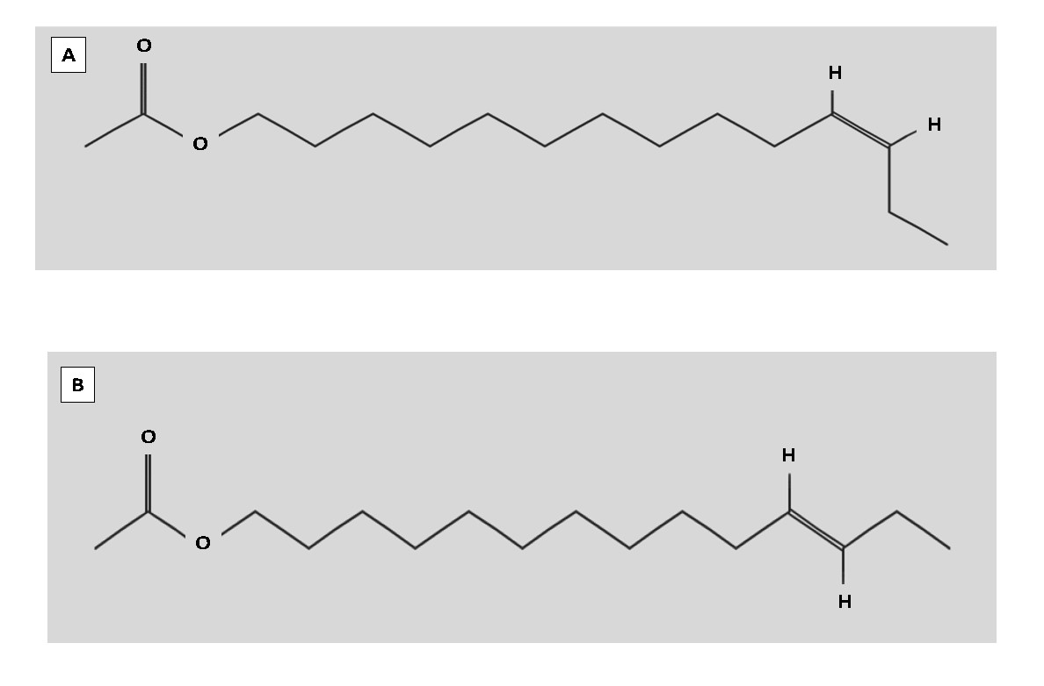

Figure 2-1. (A) Chemical structure of (Z)-11-tetradecenyl acetate, the major sex pheromone molecule produced primarily by Z strain females. National Center for Biotechnology Information. Source: PubChem Compound Database; CID=5367692. Reprinted with permission from Pubchem Open Chemistry Database

https://pubchem.ncbi.nlm.nih.gov/compound/5367692 (November 6, 2018). (B) Chemical structure of (E)-11-tetradecenyl acetate, the major sex pheromone molecule produced by E strain females. National Center for Biotechnology Information. Source: PubChem Compound Database; CID=5367650. Reprinted with permission from Pubchem Open Chemistry Database https://pubchem.ncbi.nlm.nih.gov/compound/5367650 (November 6, 2018).

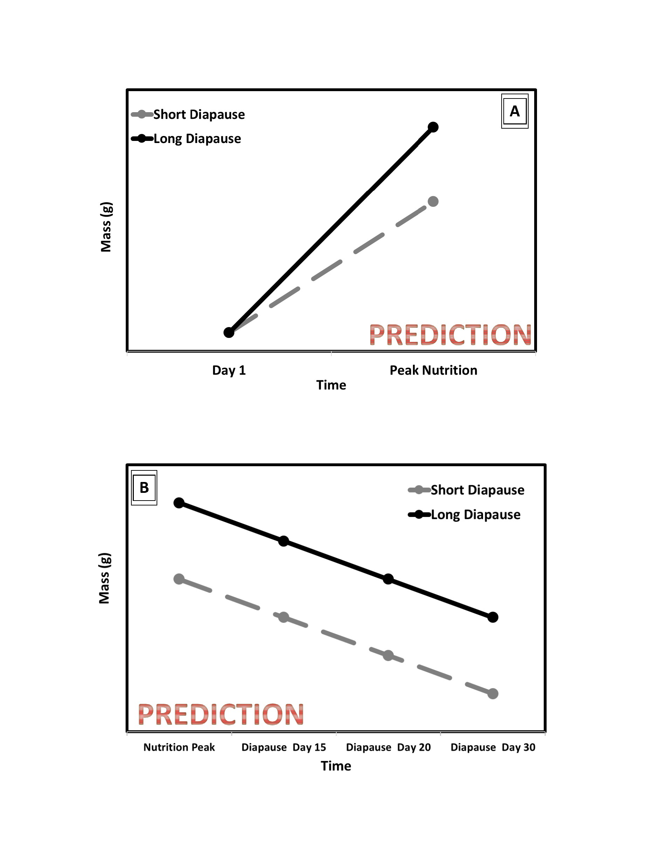

Figure 2-2. Hypothesis based prediction of the relationship between diapause genotype and lipid storage in preparation for diapause (A) and depletion during diapause (B).

CHAPTER 3

EUROPEAN CORN BORER: THE RELATIONSHIP BETWEEN STORED RESOURCES AND

DIAPAUSE TIMING

3.1 Background

According to the National Oceanic and Atmospheric Administration, 2016 was the warmest year on record and temperature increases are expected to continue through the year 2100 (NOAA, 2017; DeLucia, 2008; IPCC, 2013). As seasonal temperatures increase, the duration of warm summers will expand, cool winters will contract, and temperatures during the spring and fall will become less predictable (NOAA, 2016; DeLucia et al., 2008). Animals monitor variation in seasonal factors like temperature and photoperiod (daylight hours) because these factors can affect the availability of nutrition, mates, and habitat. Seasonality predictably cycles between conditions that are favorable for insect activity and conditions that are stressful and unfavorable. Many temperate-dwelling insects protect themselves from seasonal stress by entering diapause before their environment becomes unfavorable (Koštál, 2006).

Insects in diapause can survive for months exposed to harsh conditions and typically do so without access to nutrition by lowering their metabolic activity and suspending their development (Nechols et al., 1999; Hahn and Denlinger, 2007). Before the environment becomes unfavorable, insects prepare for diapause by accumulating and storing nutrients in the form of lipids, proteins, and carbohydrates (Hahn and Denlinger, 2007; Hahn and ­­Denlinger, 2011). Increases in nutrient storage ahead of diapause have been reported as increased protein storage in Colorado potato beetles (*Leptinotarsa decemlineata*) (Kort and Koopmanschap, 1994) and southwestern corn borers (*Diatraea grandiosella*) (Brown and Chippendale 1978), and increased lipid storage in the pink bollworm (*Pectinophora gossypiella*) (Adkisson et al., 1963) and *Culex pipens* mosquitoes (Mitchell and Briegel, 1989), among others. The energy insects store during diapause preparation fuels insect metabolism during diapause, and after diapause these stored resources are redirected to accomplish post-diapause functions. However, metabolic activity for many insects is temperature dependent. Thus, insects preparing for diapause in warmer environments may struggle to meet the energy demands of increased metabolism and possibly divert resources away from storage.

Insects entering diapause without adequate nutrition stores may exit diapause before winter ends, leaving them exposed to an unfavorable environment and thereby increasing mortality. A study using the blowfly *Calliphora vicina* (Robineau-Desvoidy) as a model explored the effect of nutrition on the duration of diapause (Saunders, 1997). The authors found that when diet was restricted, larvae entered diapause with less mass and remained in diapause for a shorter period compared to larvae given an unrestricted diet (Saunders, 1997). Insects that exit diapause early could be exposed to stressful low winter temperatures or they may not have enough stored nutrients and other metabolic substrates remaining to meet the anabolic requirements for post-diapause development, metamorphosis, repair, and other post-diapause activities like reproduction (Hahn and Denlinger, 2007; Sinclair, 2015).

Warmer and more variable fall and winter temperatures will increase insect metabolic activity and could deplete nutrition stores because insect metabolism is proportional to the environmental temperatures they experience (Bradshaw and Holzapfel, 2006; Hahn and Denlinger, 2011; Scriber 2014, Sinclair, 2018). For example, Thompson and Davis (1981) reared *Diatraea grandiosella* Dyar moths at a single stable temperature during larval feeding and diapause preparation. Then at the onset of larval diapause, some moths were held at warmer and more variable temperatures while others were held in cooler and more stable temperatures. Between the two groups, the moths held in warmer and more variable conditions depleted significantly more lipids by the end of larval diapause (Thompson and Davis, 1981). They showed that insects deplete their nutrition stores differently based on the temperatures they experience during the diapause period (Thompson and Davis, 1981).

Warmer fall temperatures during diapause preparation could increase metabolic rates and redirect resources away from nutrient storage. Insects unable to build up enough stored energy before the onset of winter may be unable to enter diapause. Similarly, warmer winter temperatures could increase the metabolic rate of diapausing insects, causing them to deplete stored energy before environmental conditions become favorable, and this could lead to mortality. Surviving diapause with reduced resources could also affect the performance of insects after diapause, limiting critical functions like dispersal, mating, and fecundity.

*Ostrinia nubilalis* (European corn borer) is an excellent model to understand how warmer fall temperatures might influence nutrition storage ahead of diapause, as well as the role of warmer winter temperatures on energy depletion during diapause. European corn borers exist as at least two naturally segregating, genetically distinct strains with unique diapause genotypes. Regardless of genotype, these two strains can and do occur at the same latitude and experience the same fall and winter conditions in some sites, however each strain expresses a different length of diapause. Larvae with the long-diapause genotype experience a warmer, longer diapause because they enter diapause earlier in the fall and exit later the next spring. Alternatively, larvae with the short-diapause genotype experience a shorter, cooler diapause because they enter diapause later in the fall and exit earlier the next spring. Comparing nutrition storage strategies between these two strains could build our understanding of how insects might adjust to warming winter temperatures as Earth’s climate changes.

European corn borers with the short-diapause genotype could provide an example of how climate change might negatively impact insect populations. Because warmer temperatures increase metabolic activity in insects, climate change for larvae with the short-diapause genotype may deplete their nutrient stores prematurely, causing diapausing larvae to exit diapause early and be exposed to unfavorable seasonal stress. The effects of climate change could also be positive for some insects. If the metabolic effects of warmer diapause temperatures can be mitigated by larger nutrient stores, then insects that utilize a strategy of storing more nutrients ahead of diapause may thrive, like long-diapause genotype European corn borers.

Warmer fall temperatures experienced by the two strains of European corn borers could lead to increased metabolic activity and in turn increase the share of energy required to fuel their metabolism ahead of diapause. During diapause, both strains rely on stored nutrients to fuel their suppressed metabolism and both strains experience the same thermal environment. Unless their metabolism is significantly influenced by diapause genotype, metabolic activity during diapause should be similar between the two strains. I predict the genotype that survives the longer, warmer diapause period will accumulate more nutrient stores prior to diapause compared to the genotype with a shorter larval diapause. However, during diapause, and regardless of diapause genotype, I expect that larvae will deplete nutrient stores at a similar rate. To investigate the relationship between diapause length and nutrient storage, lipid stores at the start of diapause and during diapause were measured in each strain. This research showed that larvae with the long-diapause genotype accumulated more lipid mass at the onset of diapause compared to larvae with the short-diapause genotype. I did not detect a difference between the two strains in the rate of lipid depletion during diapause.

3.2 Methods

3.2.1 General Rearing

*Ostrinia nubilalis* eggs were provided as a courtesy from Dr. Erik Dopman's laboratory at Tufts University. The two genetically distinct European corn borer strains used during my experiment were collected as a mixture of larvae, pupae, and adults from New York State prior to 2015 and kept as separate colonies (Wadsworth et al., 2005). Strain identity was determined genotypically using the *pgFAR* autosomal gene (Lassance et al., 2010). This gene codes for an important enzyme involved in determining the female sex-pheromone blend and is partly responsible for maintaining strain differences. The *pgFAR-Z* allele is carried by the Z-strain larvae and the *pgFAR-E* allele is carried by the E-strain larvae, and each allele produces a distinct pheromone blend (Lassance et al., 2010). For the duration of the experiment, colonies of each genotype were reared at 26°C under a 16L:8D photoperiod to promote continuous development.

Individuals intended for experimentation were collected as eggs from each colony and organized into "biological cohorts". A biological cohort was defined as clutches of eggs oviposited on a single day by females of the same strain. Initially, eggs from each biological cohort were held under a 16L:8D photoperiod, 23°C and 65% rH until they hatched. Upon hatching, each biological cohort was divided and reared in either the diapause-inducing treatment (12L:12D photoperiod, 23°C, and 65% rH) or the non-diapause treatment (16L:8D photoperiod, 23°C, and 65% rH). Larvae from each biological cohort were reared together in groups and provided artificial European corn borer diet ad libitum (Frontier Agricultural Sciences, Newark, DE, Product F9478B). When larvae from each biological cohort within each treatment reached the end of the fourth instar, they were separated and reared individually in 32-well bioassay trays (Frontier Agricultural Sciences, Newark DE, Product RT32W). Each well of the bioassay tray was provisioned with diet and returned to either diapause-inducing or non-diapause treatment conditions until sampling.

3.2.2 Experiment 1: Estimating the Onset of Diapause and Using Metabolic Activity to Classify the Intensity of Diapause-Programmed Larvae

I tracked the developmental stages of individuals exposed to diapause-inducing and non-diapause treatments for forty days starting on day one of the last larval instar. To determine the onset of diapause, the development of individuals reared in the non-diapause treatment was compared to larvae in the diapause treatment. Because non-diapause larvae eventually pupate, the timing of pupation in the non-diapause treatment was used to estimate the start of diapause for larvae in the diapause treatment. Diapause-programmed larvae that pupated after the estimated onset of diapause but before the end of the 40-day trial were classified as shallow-diapause larvae, and larvae that did not pupate during the 40-day trial were classified as deep-diapause larvae.

Carbon dioxide production and wet mass were measured starting on the first day of the last larval instar. To measure CO2 production, larvae were first isolated into airtight respirometry chambers (Air-Tite, Virginia Beach, VA., product AL5) fitted with a three-position stopcock. A single larva was placed into a chamber filled with CO2 -free air. To remove CO2, atmospheric air was pumped through a column of Drierite (W.A. Hammond Drierite, Xena, OH., stock 24025) to absorb moisture from the airstream and a column of Ascarite (Fisher Scientific, Waltman, WA., catalog AC208081000) to remove CO2. The airstream was then bubbled through water with a pH of 4 to humidify the air. This CO2-free air was then pumped into the respirometry chamber to replace the atmospheric air in the chamber, and finally larvae were sealed into the CO2 -freechamber. Larvae were then held in these chambers for approximately 1 hour and the exact hold time of each individual larvae was recorded. After the hold time elapsed, each sealed chamber was attached to a gas analyzer (Li-cor, Lincoln, NE., model LI-6262) to quantify the CO2 produced by each larva. These data were visualized using Expedata software (Sable Systems International, Las Vegas, NV.). The day wet mass peaked was used as a clearly identifiable developmental timepoint to compare CO2 production between genotypes and treatments.

3.2.3 Experiment 2: Estimating the Onset of Wandering and Sampling Larvae for Lean Mass and Lipid Mass

Stored energy was measured at the onset of diapause, because energy stores are at their peak at the start of diapause. I diagnosed the onset of diapause in final larval instar larvae by assaying for the termination of frass production, which signifies the start of the wandering stage. The wandering stage is a developmental step that occurs at the end of the larval feeding stage in continuous developing larvae and those programmed for diapause (Sakurai et al., 1998). Larvae were removed from artificial diet and held in isolation for thirty minutes. After thirty minutes of isolation, larvae that did not produce frass were recorded as wandering. Using this wandering assay, I tracked the population of larvae for up to forty days and recorded the following developmental events: 1) the day that larvae eclose into the final instar, 2) the wandering day, and 3) pupation. All larval samples intended for lean mass and lipid measurements were assayed for wandering only once and larvae determined not to be wandering were removed from the experiment.

To investigate the relationship between nutrition stores and diapause length genotype, lean mass and lipid mass were measured in larvae from each treatment at the onset of the last instar, at the onset of diapause, and at several points during diapause. A subset of larvae was sampled on the first day of the final larval instar to measure the amount of lipid and lean mass stored at the beginning of the final larval instar growth stage, a critical life stage for most holometabolous insects. Then, another subset of larvae was sampled on the wandering day of the final larval instar to capture the peak of lipid mass and lean mass at the onset of diapause or non-diapause development. Finally, to capture the rate of nutrition depletion during diapause, diapause-programmed larvae were sampled 15, 20, or 30 days after the onset of diapause.

Sampled larvae were assigned a unique identifier and freeze-dried under vacuum to remove water. When the mass of each freeze-dried larvae varied by less than 1% over a 24-hour period, the final dry mass measurement was recorded. After drying, 657 larval samples were then assigned to one of the 43 extraction cohorts and stored in a -80°C freezer. Each extraction cohort consisted of larvae from each biological cohort. Lean mass and lipid mass were measured for each larva sampled. First, lean mass was separated from lipid mass using a slightly modified Folch liquid-liquid extraction method (Folch et al., 1957). Larval samples were solubilized in pre-weighed microcentrifuge tubes (USA Scientific, Ocala, FL., 1420-8700) using a 3:1 solvent mixture of hexanes and methanol. The hexanes layer containing lipids was siphoned away from the methanol layer and collected in pre-weighed 15-mL glass vials (Milipore-Sigma, St. Louis, MO., 27347) and both layers were saved. Lean mass was estimated by drying away the methanol from the solubilized insect tissue and weighing the dry tissue powder. To estimate lipid mass, the hexanes were dried away from the lipids and the dry lipids were weighed.

3.2.4 Statistical Analyses

All statistical analyses were performed using R studio software (version 1.1.383). In experiment 1, diapause status was measured in 100 larvae for 40 days. The percentage of individuals in diapause was calculated on each observation day as the number of individuals that remained larva divided by the total number of individuals alive (larvae and pupa). Measurements of CO2 production and wet mass were taken for 100 individuals and analyzed using a linear model. The production of CO2 was weighted by wet mass and photoperiod, diapause genotype, and diapause phenotype were each independent variables used to explain the response of CO2 production. Finally, CO2 was compared using the estimates of wandering day from experiment 2 where photoperiod, diapause genotype, and diapause phenotype were each independent variables used to explain the response of CO2 production.

In experiment 2, wandering day was calculated as the total number of days between eclosion into the final larval instar and the day frass production ended for each sampled larva. Wandering day was measured in 48 individuals and analyzed using a generalized linear mixed effects model. The statistical model to explain differences in wandering day included: diapause genotype and photoperiod as fixed effects, diapause genotype and photoperiod as interacting effects, and biological cohort as a random factor. Lipid stores were measured in 266 individuals and analyzed using a generalized linear mixed effects model. The statistical model to explain lipid mass prior to the onset of diapause included: diapause genotype and photoperiod as fixed effects, diapause genotype and photoperiod as interacting fixed effects, and lean mass was a covariate (Table 3-1). The model to explain lipid mass depletion during diapause included: diapause genotype and sample day as fixed effects, diapause genotype and sample day as interacting fixed effects, and lean mass was a covariate (Table 3-2). Lean mass was measured in 338 individuals and analyzed using a generalized linear mixed effects model. The statistical model to explain lean mass prior to the onset of diapause included: diapause genotype and photoperiod as fixed effects and diapause genotype and photoperiod as interacting fixed effects (Table 3-3). The model to explain lean mass depletion during diapause included: diapause genotype and sample day as fixed effects and diapause genotype and sample day as interacting fixed effects (Table 3-4). Biological cohort was also included in each generalized linear model as nested within extraction cohort, and extraction cohort was used as a random factor.

3.3 Results

3.3.1 Experiment 1: Metabolic Activity

Wet mass was measured throughout the metabolic assay and the day wet mass peaked was calculated for diapause-programmed larvae and non-diapause larvae in short-day and long day conditions. In the non-diapause treatment, long-diapause genotype individuals peaked in mass on day 5 and short-diapause genotype larvae peaked in mass on day 3 (Figure 3-1A). In diapause-programming conditions, mass peaked in long-diapause genotype larvae on day 9 and short-diapause genotype larvae peaked in mass on day 6 (Figure 3-1B). The amount of CO2 produced was weighted by wet mass and compared between diapause genotypes and photoperiod treatments to capture the effect of day length on metabolic activity. I found that regardless of diapause genotype, on the day wet mass peaked diapause-programmed individuals produced significantly less CO2 than their non-diapause counterparts (long-diapause genotype: t-value=4.50, Df=30, p-value<0.000; short-diapause genotype: t-value=5.00, Df=43, p-value<0.000) (Figure 3-2A and Figure 3-2B) (Table 3-5A and Table 3-5B). Long-diapause genotype larvae produced less CO2 than short-diapause genotype larvae in each photoperiod treatment (diapause programming: t-value=-5.51, Df=26, p-value<0.000; non-diapause: t-value=-3.74, Df=47, p-value<0.001) (Figure 3-3A and Figure 3-3B) (Table 3-5C and Table 3-5D).

Individuals in diapause programming conditions were characterized as being in deep-diapause if they remained in the larval stage throughout the 30-day post-feeding trial period. Diapause-programmed larvae that pupated before the end of the 30-day trial period, but after all the larvae in the non-diapause treatment group pupated, were characterized as being in shallow-diapause. Long-diapause genotype larvae responded to diapause programming as expected with deep-diapause reported in 100% of individuals. In contrast, only 33% of short-diapause genotype larvae stayed in deep-diapause while 66.6% showed a shallow-diapause response, pupating before the end of the 30-day trial period despite being reared in diapause programming conditions (Figure 3-4). Carbon dioxide production on the day wet mass peaked was used to try to discriminate between diapause programmed larvae that expressed the shallow and deep diapause phenotypes to determine the extent to which metabolic activity could be used to separate the two phenotypes. The timing and the accumulation of wet mass among diapause-programmed larvae with the short-diapause genotype occurred on day 6, regardless of diapause phenotype and there was no significant difference in CO2 production between the two phenotypes (t-value=-1.03, Df=14, p-value=0.319) (Figure 3-5A and Figure 3-5B) (Table 3-5E).

Larvae used in the metabolic activity experiment were not assayed for wandering day. However, when the wandering day (estimated in experiment 2) is used as a developmental timepoint to compare metabolic activity instead of the day wet mass peaked, the results of the metabolic assay can be interpreted differently. Larvae in non-diapause conditions wandered on day 6 while larvae in diapause conditions wandered on day 10 (results are explained in experiment 2). Using wandering day to characterize the effect of day length on metabolic activity within each strain showed diapause programmed individuals produce less CO2 than their non-diapausing counterparts (long-diapause genotype: t-value=8.12, Df=46, p-value<0.000; short-diapause genotype: t-value=9.08, Df=26, p-value<0.000) (Table 3-6A and Table 3-6B). Metabolic activity for long-diapause and short-diapause genotype larvae in non-diapause conditions was compared on day 6 and revealed no significant difference in CO2 production (t=-0.43, Df=46, p-value=0.673) (Table 3-6C). In diapause programming conditions, metabolic activity was compared on day 10 and there was no detectable difference in CO2 production between long-diapause and short-diapause larvae (t-value=0.91, Df=26, p-value=0.369) (Table 3-6D). Carbon dioxide production the wandering day 10 was used to try to discriminate between diapause programmed larvae that expressed the shallow and deep diapause phenotypes to determine the extent to which metabolic activity could be used to separate the two phenotypes. The timing of wandering for all diapause-programmed larvae occurred on day 10, but there is no data available for short-diapause larvae in deep-diapause on day 10. However, comparing CO2 production on days 9 and 11 show no significant difference in metabolic activity (day 9: t-value=1.85, Df=14, p-value=0.085; day 11: t-value=0.66, Df=3, p-value=0.554) (Table 3-6E and Table 3-6F).

3.3.2 Experiment 2: Stored Lipids and Lean Mass

The termination of feeding in European corn borers occurs at the end of the final larval instar and signifies the onset of the wandering stage. Wandering was calculated as the number of days needed to terminate feeding after eclosion into the final larval instar in non-diapause conditions and diapause conditions respectively (Figure 3-6A and Figure 3-6B). Short-diapause genotype and long-diapause genotype larvae in long-day conditions both wandered 6 days after entering the final larval instar (mean=5.89 days, SE=0.60 days, p-value=0.663) (Table 3-7A). Similarly, both short-diapause genotype and long-diapause genotype larvae in non-diapause conditions wander 10 days after entering the last larval instar (mean=10.46 days, SE=1.98 days, p-value=0.401) (Table 3-7B).

On the first day of the last larval instar, diapause-programmed larvae had accumulated larger lipid stores compared to their non-diapausing counterparts in both genotypes, but there was no genotype-specific difference in lipid content on day one of the last larval instar (t value= -2.73, Df= 75.9, p-value= 0.008) (Table 3-8A). Lean mass on the first day of the final larval instar was also not different between the two genotypes regardless of photoperiodic rearing conditions (t-value= 2.03, Df= 5.9, p-value= 0.089) (Table 3-8B). Similarities in lean mass and lipid mass accumulation at the start of the final larval instar show that the two contrasting diapause genotypes begin the final larval instar with the same amount of stored nutrition.

Once larvae reached the wandering stage, increases in lean mass accumulation and lipid stores were both clearly associated with diapause programming and diapause genotype. On the wandering day, larvae with both the long-diapause genotype and the short-diapause genotype in diapause-programming conditions accumulated more lean mass and stored more fat than their counterparts in non-diapause conditions (lean mass: t-value= -9.70, Df=133.3, p-value< 0.000; lipid mass: t-value= -10.23, Df= 191.6, p-value< 0.000) (Figure 3-7A and Figure 3-7B) (Table 3-8C and 3-8D). Additionally, long-diapause genotype individuals in diapause-programming and non-diapause conditions had greater lean mass and bigger fat stores compared to short-diapause genotype individuals in those same conditions (lean mass: t-value= 6.85, Df= 10.9, p-value< 0.000; lipid mass: t-value= 4.08, DF= 186.8, p-value <0.000) (Table 3-8C and 3-8D).

To assess whether the long-diapause and short-diapause genotypes differed in utilization of their nutrient stores during diapause, fat stores and lean mass were also measured in diapause-programmed larvae 15, 20, and 30 days after the onset of diapause. Long-diapause genotype individuals had significantly more lean mass at the onset of diapause than short-diapause larvae (t-value=2.45, Df=10.7, p- value=0.033) (Figure 3-8A) (Table 3-9A). Long-diapause genotype individuals also had larger fat stores at the onset of diapause than short-diapause genotype larvae (t-value=4.74, Df=16.7, p-value=0.0002) (Figure 3-8B) (Table 3-9B). However, within each diapause genotype, lean mass (Table 3-10A and 3-10B) and fat stores (Table 3-10C and 3-10D) did not significantly decline during diapause, with one notable exception. Fat stores among short-diapause individuals were significantly lower when sampled 15 days after wandering in comparison to other sample days (t-value=-3.90, Df=111.4, p-value<0.000) (Table 3-10D).

3.4 Discussion and Conclusions

The induction of diapause protects insects from unfavorable environmental changes and for many insects, once diapause begins metabolic activity is fueled by stored nutrition (Hahn and Denlinger, 2007; Hahn and Denlinger, 2011; Sinclair, 2015). Diapause length for many insects is determined by a highly heritable diapause genotype. European corn borers have at least two different diapause genotypes, each with differences in regulating the response to the environmental cues used to trigger diapause, the physiological changes associated with induction of diapause, and most notably the duration of diapause (McLeod, 1976; Coates et al., 2004; Dopman et al, 2004; Calcagno et al., 2007; Ikten et al., 2011). My research leverages between-strain genetic variation in diapause duration in *O. nubilalis* to test the relationship between diapause length and nutrition storage. I found, European corn borers preparing for diapause were shown to have a lower metabolic rate than non-diapause larvae. In diapause programming conditions, larvae with the long-diapause genotype expressed a deep-diapause phenotype while larvae with the short-diapause genotype expressed a deep-diapause and a shallow-diapause phenotype. Diapause genotype was also associated with differences in lean mass and lipid mass accumulation. Larvae with the long-diapause genotype and had more lean mass and stored more lipids than larvae with the short-diapause genotype. Lean mass and lipid mass depletion during diapause did not differ significantly between the two diapause genotypes.

Characterizing the effects climate on diapause preparation and diapause length could provide a possible target for the management of pests that use this life history strategy to survive winter stress. Many insects survive diapause by increasing their nutrition stores and suppressing their metabolic activity to reduce the consumption of those stored nutrients. Warmer fall temperatures could increase metabolic activity and possibly reduce lipid stores during diapause preparations and/or drain lipid stores during the early portion of diapause before the onset of winter (Adkisson et al. 1963; Williams et al., 2012; Wipking et al., 1995). Similarly, warmer winter temperatures during diapause could prematurely drain stored energy causing insects to die during diapause or emerge from diapause the next spring without sufficient reserves to restart their lifecycle, including enough energy to support dispersing, mating, and reproducing.

Warmer and more variable temperatures at the beginning of diapause have been found to reduce nutrition stores by increasing metabolic activity and draining stored energy before the onset of winter. For example, a study by Williams et al. (2012) on the effect of temperatures on stored nutrition suggests that diapausing insects experiencing temperature variations with greater warm times at the beginning of diapause store less resources and deplete those resources faster than insects in thermally stable environments before the onset of winter. To investigate the relationship between fluctuating warm temperatures and nutrition storage, these researchers reared (*Erynnis propertius* (Scudder and Burgess)) caterpillars that originated from environments that differed in thermal stability in a reciprocal common garden experiment with stable and fluctuating thermal regimens (Williams et al., 2012). Larvae reared in stable conditions stored significantly more lipids and entered dormancy 3-4 weeks later compared to their counterparts reared in thermally variable environments (Williams et al., 2012). European corn borers that do not accumulate enough energy ahead of diapause could fail to enter diapause, terminate diapause prematurely, or sub-optimal nutrition could lead to reductions in post-diapause adult functions.

Nutrition storage prior to the onset of diapause has repeatedly been shown to be a pivotal step in diapause preparation and this result has been demonstrated across a number of taxa (Adkisson et al., 1963; Mitchell and Briegel, 1989; Hahn and Denlinger, 2007). Eventually, climate change is expected to cause summer temperatures to expand, and fall and winter temperatures to rise, so how insects manage their nutrition during diapause preparation could explain how some insects might adjust to warmer winters. Results of a previous study show that diapause programming among European corn borers is associated with increased lipid accumulation during diapause preparation compared to continuously developing larvae. Vukašinović et al. (2013) measured lipid stores in European corn borers they collected from maize fields in the fall and found that larvae preparing for diapause accumulated more lipids compared to non-diapause larvae (Vukašinović et al., 2013). genotypesTaken together, the results from Vukašinović et al. (2013) and my current study show an association between diapause programming and increased nutrition accumulation ahead of diapause however, they did not test for a correlation between diapause length and lipid accumulation, as I have shown here. In nature, long-diapause genotype larvae enter diapause earlier in the fall and exit later in the spring compared to larvae with the short-diapause genotype. Because of the differences in the timing of diapause, long-diapause genotype larvae diapause at higher temperatures and remain in diapause longer than larvae with the short-diapause genotype. My research shows that larvae with the long-diapause genotype store more lipids during diapause preparation compared to larvae preparing for a shorter diapause period. Long-diapause larvae experiencing a warmer diapause period may have a higher metabolic rate and, in turn may need larger energy stores to fuel their higher metabolic rate, compared to larvae with the short diapause genotype. The larger lipid stores of European corn borers experiencing longer warmer diapause periods could function to meet that increased demand for metabolic fuel.

Increasing seasonal temperatures are expanding the duration of the warm growing season (IPCC, 2013; NOAA, 2017), however the photoperiod cues that insects use to predict seasonality will remain unchanged. The relationship between increasing temperatures, diapause length, and nutrition accumulation could be useful for estimating changes in the seasonality of insect populations. If insects manage to adjust to the longer growing season by delaying the onset of diapause could be advantaged For European corn borer, access to longer growing seasons could provide more time to produce additional generations or to increase nutrition stores before the onset of diapause. The association between increasing seasonal temperatures and the delayed induction of diapause in *W. smithii* (pitcher plant mosquito) shown by Bradshaw et al. (2004) is one example of how insects could adjust to climate change and gain access to longer growing seasons . Researchers monitored the critical photoperiod of pitcher plant mosquitoes for decades. Critical photoperiod for this study corresponds to the number of daylight hours at which diapause is induced among 50% of larvae in laboratory conditions (Bradshaw et al., 2004). After decades of observations, the critical photoperiod of these mosquitoes shifted down from 15.79 hours to 15.19 hours (Bradshaw et al., 2004). The shift in critical photoperiod corresponds to a 9-day delay in the onset of diapause in the fall (Bradshaw et al., 2004). This delay in diapause initiation gives mosquito larvae longer to grow and accumulate nutrition reserves to get them through diapause.

A similar shift in critical photoperiod has also been noted in the fall webworm (*Hyphantria cunea* (Drury)). Gomi et al. collected fall webworm larvae from the same field site in 1988 and

2002, reared them at 20°C, and measured their response to a range of photoperiods between 14L:10D to 14.5L:9.5D. The photoperiod that induced diapause among larvae collected in 2002 was shorted by 8 minutes compared to larvae collected in 1988 (Gomi et al., 2007). Taken together, these two studies implicate longer growing seasons in increasing access to nutrition ahead of diapause (pitcher plant mosquito) and increased voltinism (fall webworm). If European corn borers respond to longer growing seasons with delayed diapause induction, they would avoid the risk of premature energy depletion associated with diapause induction at higher temperatures, increase nutrition stores ahead of diapause, or possibly experience increases in voltinism (Bradshaw and Holzapfel, 2001; Gomi et al., 2007; Sinclair, 2015; Thompson and Davis, 1981; Williams et al., 2012). In my data, there is an indirect association between a longer diapause length and increasing lipid stores. My results show that diapause-programmed European corn borers prepare for diapause by increasing their nutrition stores and larvae with the long-diapause genotype store more lipids than larvae with the short-diapause genotype (Figure 3-8B). The difference in the timing of diapause entry and exit and differences in lipid stores between the two diapause genotypes evidenced in my research suggests that metabolic activity during a longer diapause is met by increasing nutrition stores ahead of diapause. As climate change increases growing seasons, variation in the response of each genotype to the environmental cues that induce diapause could advance the termination of diapause in the short-diapause genotype and the delay of diapause in the long-diapause genotype.

The long-diapause genotype responded to diapause programming with the deep-diapause phenotype while diapause programming for short-diapause genotype individuals lead to at least two different phenotypes; a shallow-diapause phenotype and a deep-diapause phenotype (Figure 3-9). Deep-diapause larvae remained in diapause for the entire duration of the 40-day trial while larvae in shallow-diapause terminated diapause at some point prior to the end of the trial. The two phenotypic responses to diapause programming observed in the short-diapause genotype could suggest that an increased sensitivity to the cues that terminate diapause and it could be one way European corn borers take advantage of growing seasons that begin earlier (McLeod and Beck, 1963). Increasing temperatures during early spring will expand growing seasons during the time when short-diapause genotype larvae are ending their term in diapause. Short-diapause larvae in a state of shallow-diapause could respond to increased spring temperatures by terminating diapause earlier. Larvae in shallow-diapause that terminate diapause early will have access to the longer growing season, increasing their active period, and possibly increasing the number of generations produced annually if there is enough time and resources to complete that additional generation.

Ahead of unfavorable seasonal change European corn borers integrate changes in photoperiod and temperature, and once these environmental factors reach critical thresholds diapause is programmed at the end of the last larval instar. Long-diapause genotype larvae exposed to increased temperatures at the end of the growing seasons could experience increased voltinism as higher temperatures delay the onset of diapause. Photoperiod will not change as temperatures continue to increase, however increased temperatures have the potential to avert diapause by shunting individuals into a non-diapause developmental trajectory (Ikten et al., 2011; McLeod and Beck, 1963). The long-diapause larvae in these regions that avoid diapause could eventually eclose as adults and produce an additional generation of herbivorous larvae.

Longer and warmer growing seasons have the potential to increase insect feeding, mating, and voltinism. Climate change will affect insect populations, and how insects respond to climate change will determine which insects are losers and which are winners, European corn borer is no exception. European corn borer is a major agricultural pest here in the United States, accounting for up to $2 billion dollars in costs associated with managing these pests (Hyde et al. 1999). Investigating the energy requirements of diapause could expose mechanisms that regulate the timing of this tenuous life history decision. Developing strategies to manipulate the mechanisms regulating the progression of European corn borer through diapause could be valuable. Eventually, perturbing the European corn borer larvae’s ability to survive diapause by affecting how it accumulates and stores resources in preparation for diapause could be used as an added layer of pest management. Until then, the link between seasonal temperatures and global food security will become more tenuous and finding a making a comprehensive approach to dealing with the response of pest insects to climate change is imperative.

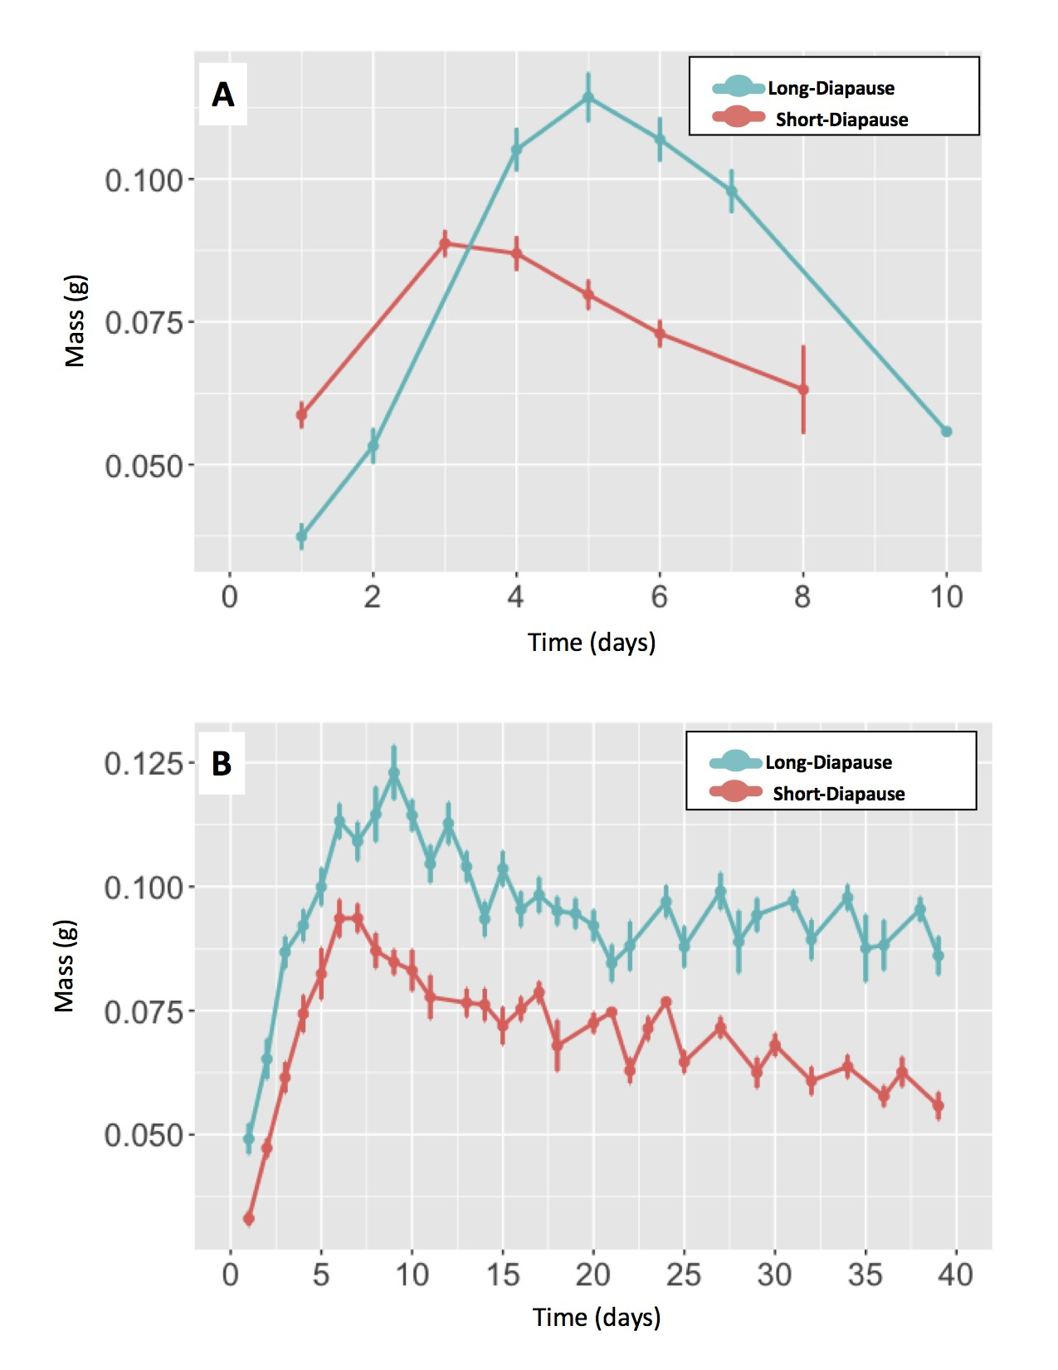

Figure 3-1. Peak wet mass accumulation between with different diapause-genotypes. When reared in non-diapause conditions (A), wet mass peaked in short-diapause genotype larvae (red) 3 days after eclosing into the last larval instar and long-diapause genotype larvae (blue) reached their peak in wet mass 5 days after eclosing into the last larval instar. Among larvae reared in diapause programming condition (B), short-diapause genotype larvae (red) reached their peak in wet mass 6 days after entering the last larval instar while long-diapause genotype larvae (blue) reached their peak in wet mass 9 days after eclosion into the last larval instar.

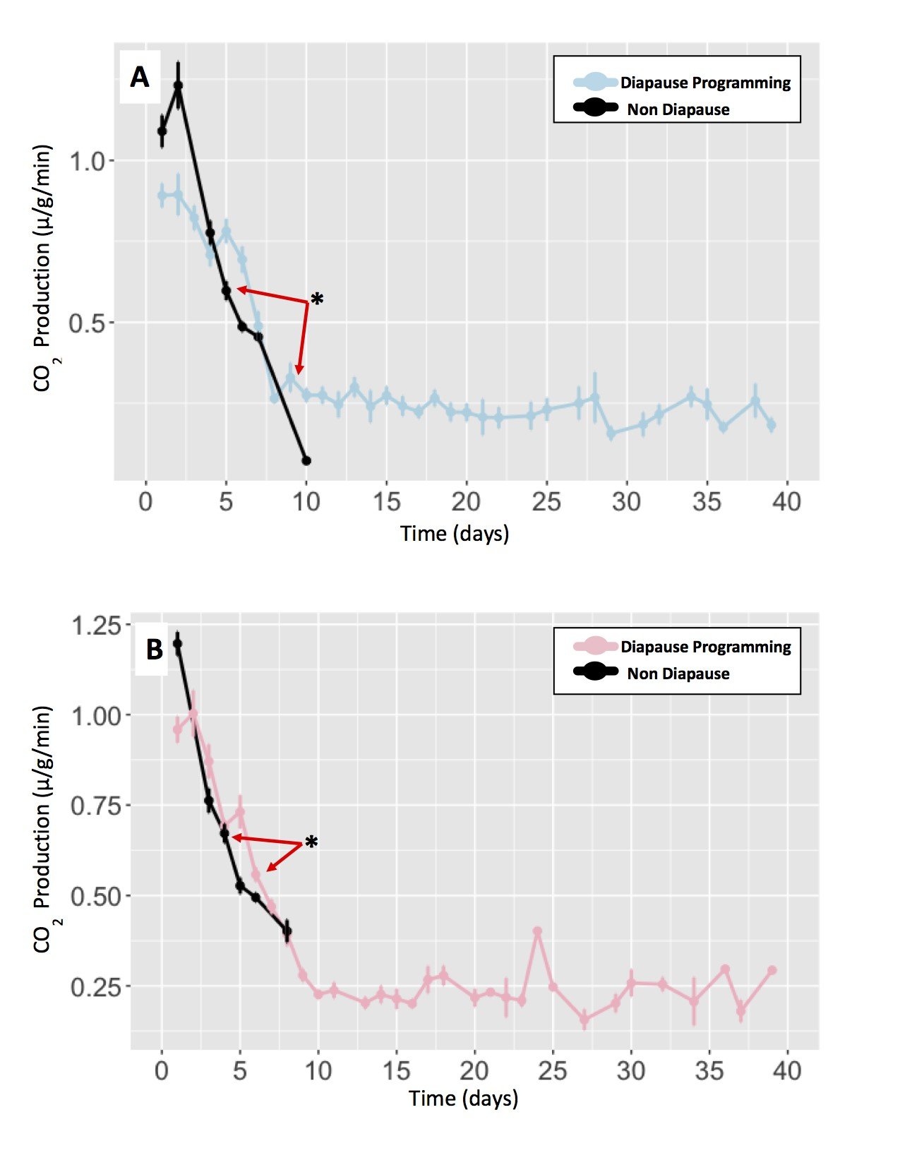

Figure 3-2. Comparison of CO2 production among larvae with the same diapause genotype. Co2 production was compared on the day wet mass peaked. Red arrows point towards wet mass peak days and asterisks "*" represent significance. (A) CO2 production compared between long-diapause genotype larvae in diapause programming conditions (blue) and non-diapause conditions (black). Mass peak days: day-9 reared in diapause programming conditions and day-5 in non-diapause conditions. CO2 production in diapause-programmed larvae was significantly different (F-statistic=22.52, DF=30, p-value*<*0.000). (B) CO2 production compared between short-diapause genotype larvae reared in diapause programming conditions (pink) and non-diapause conditions (black). Mass peak days: day-6 in diapause programming conditions and day-3 in non-diapause conditions. CO2 production in diapause-programmed larvae was significantly different (F-statistic=24.91, DF=43, p-value*<*0.000).

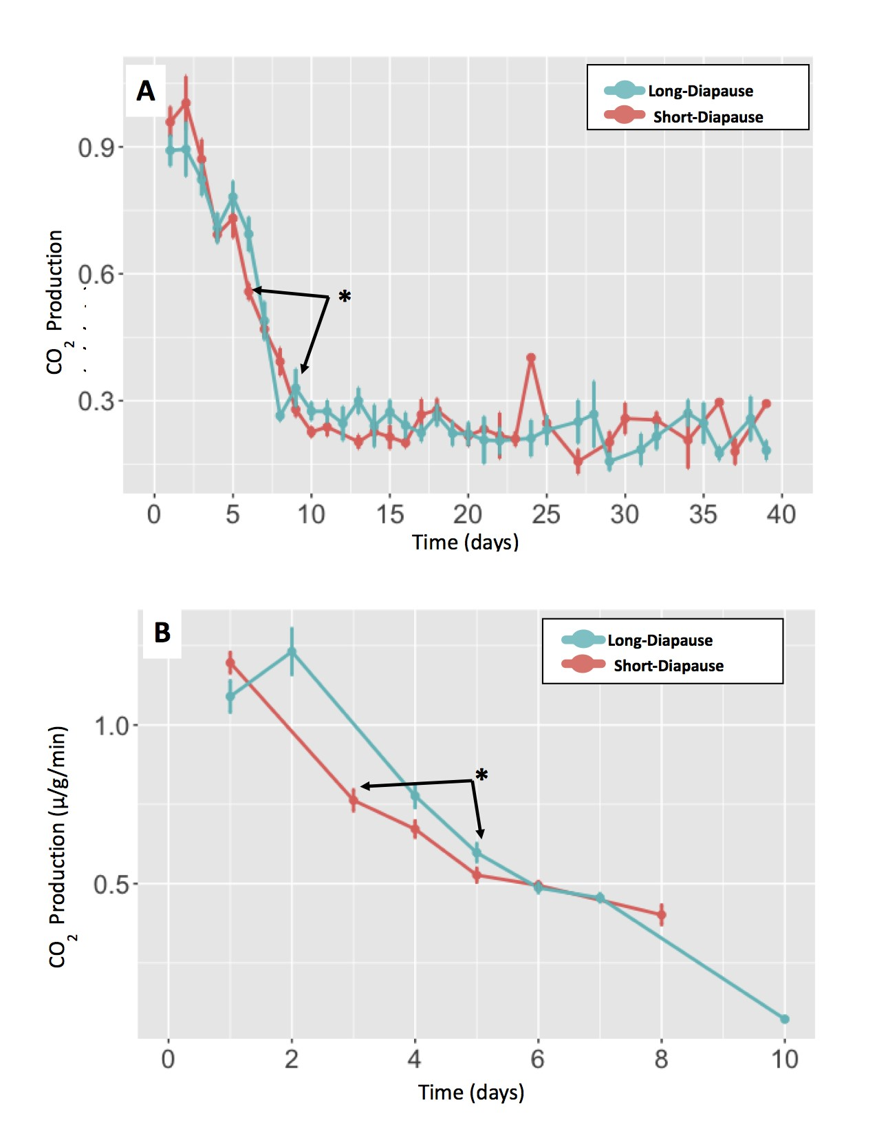

Figure 3-3. Comparison of CO2 production between larvae with different diapause genotypes. Co2 production was compared on the day wet mass peaked. Black arrows point towards wet mass peak days and asterisks "*" represent significance. (A) Comparing CO2 production between the long-diapause genotype (blue) and the short-diapause genotype (red) in diapause programming conditions. Mass peak days: day-9 for the long-diapause genotype and day-6 for the short-diapause genotype. CO2 production at day-9 was significantly different than day-6 (F-statistic=30.31, Df=26, p-value*<*0.000). (B) CO2 production comparison between the long-diapause genotype (blue) and the short-diapause genotype (red) in non-diapause conditions. Mass peak days: day-5 for the long-diapause genotype and day-3 for the short-diapause genotype. CO2 production was significantly difference on day-5 (F-statistic=13.99, Df=47, p-value*<*0.000).

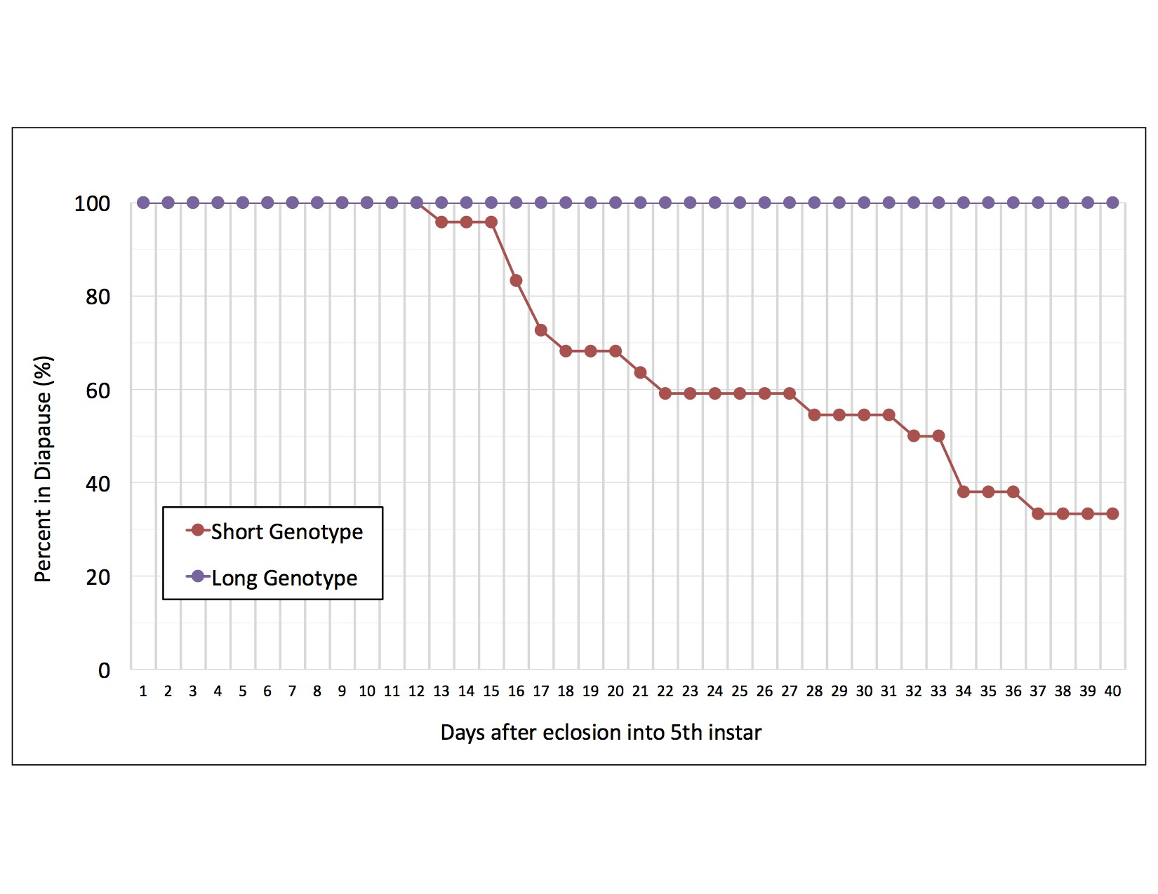

Figure 3-4. Comparison the diapause phenotype of diapause-programmed larvae during a 40-day trial. Among long-diapause genotype individuals (purple symbols), 100% remained larvae throughout the 30-day trial and were classified as deep-diapause larvae. Among the short-diapause genotype individuals (red symbols), 66.6% exited diapause before the end of the trial and classified as shallow-diapause individuals while 33.3% of individuals remained as larvae throughout the 30-day trial and were classified as deep-diapause larvae.

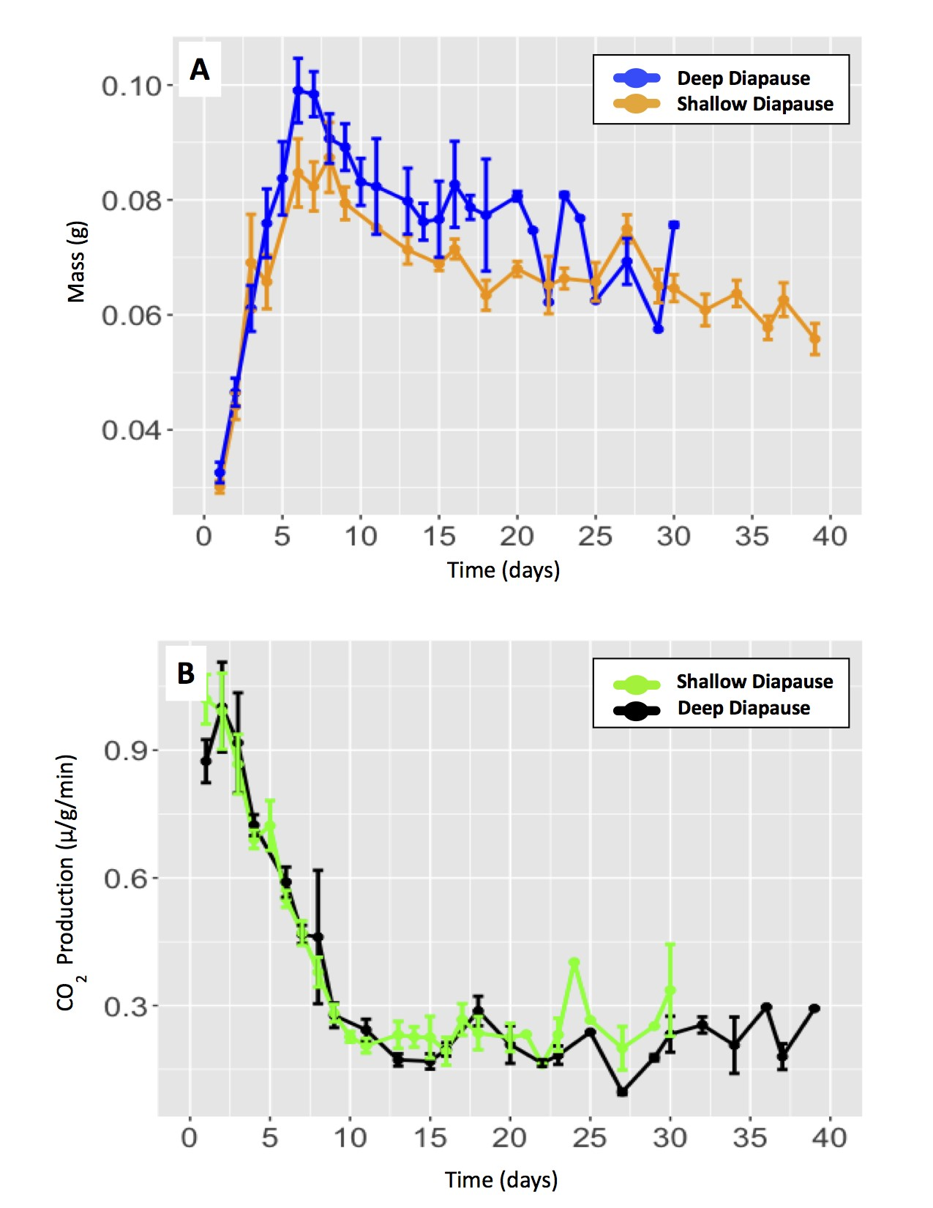

Figure 3-5. Comparison of CO2 production between different diapause phenotypes using the day wet mass peaked. (A) Comparing mass peak days between short-diapause larvae demonstrating a shallow-diapause phenotype (orange) and a deep-diapause phenotype (blue). Mass peak days: day-6 for shallow-diapause larvae and day-6 for deep-diapause larvae. (B) Comparing CO2 production between short-diapause larvae in deep-diapause (black) shallow-diapause (green). No significance difference in CO2 production between shallow-diapause and deep-diapause larvae (F-statistic=1.068, DF=14, p-value=0.319).

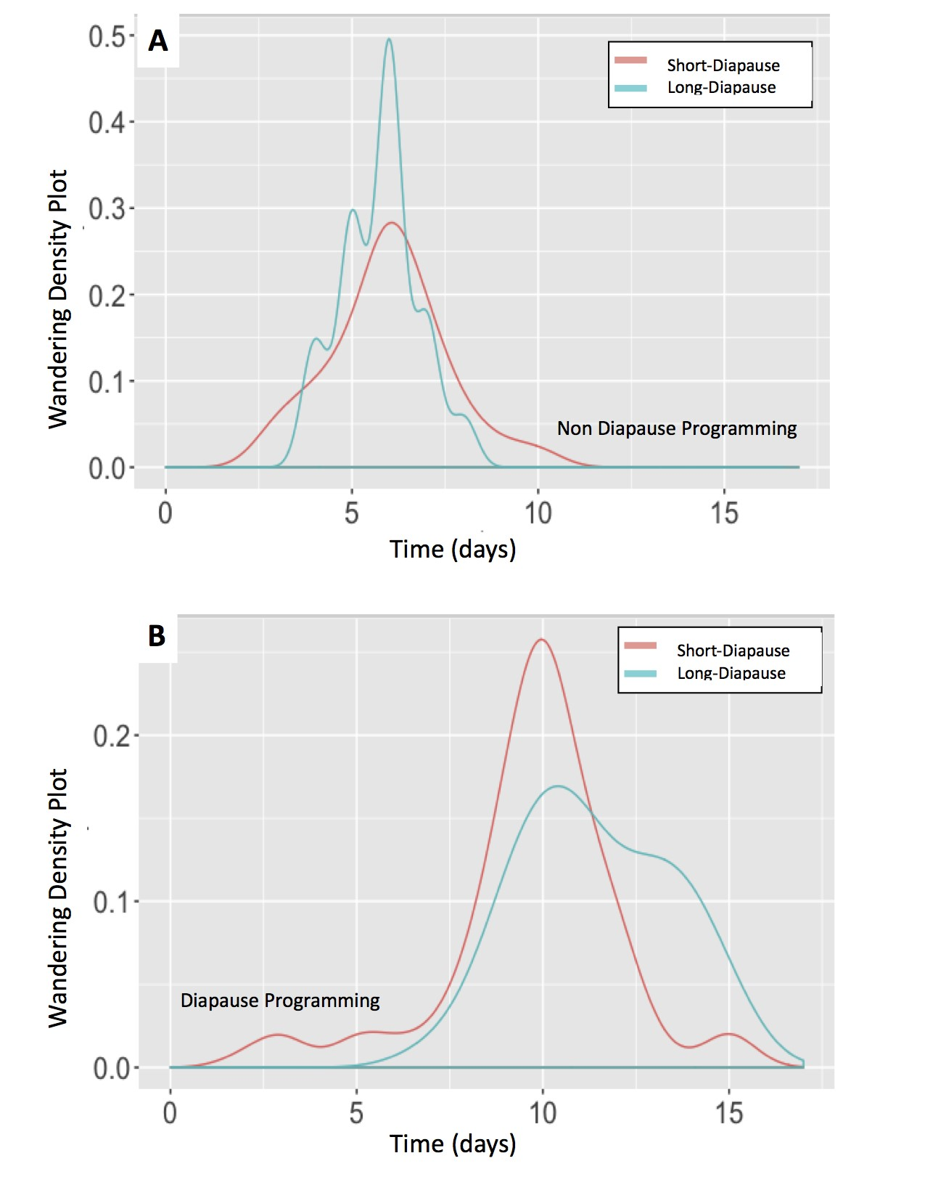

Figure 3-6. Days between eclosion into the last larval instar and the wandering day. Within each strain wandering day did not significantly differ between diapause genotype (non-diapause conditions (A): mean=5.89 days, SE=0.60 days, p-value=0.663; diapause conditions (B): mean=10.46 days, SE=1.98 days, p-value=0.401). There was a significant difference in wandering day between diapause conditions and non-diapause conditions (t-value -45.82, Df= 3381, p-value<0.000).

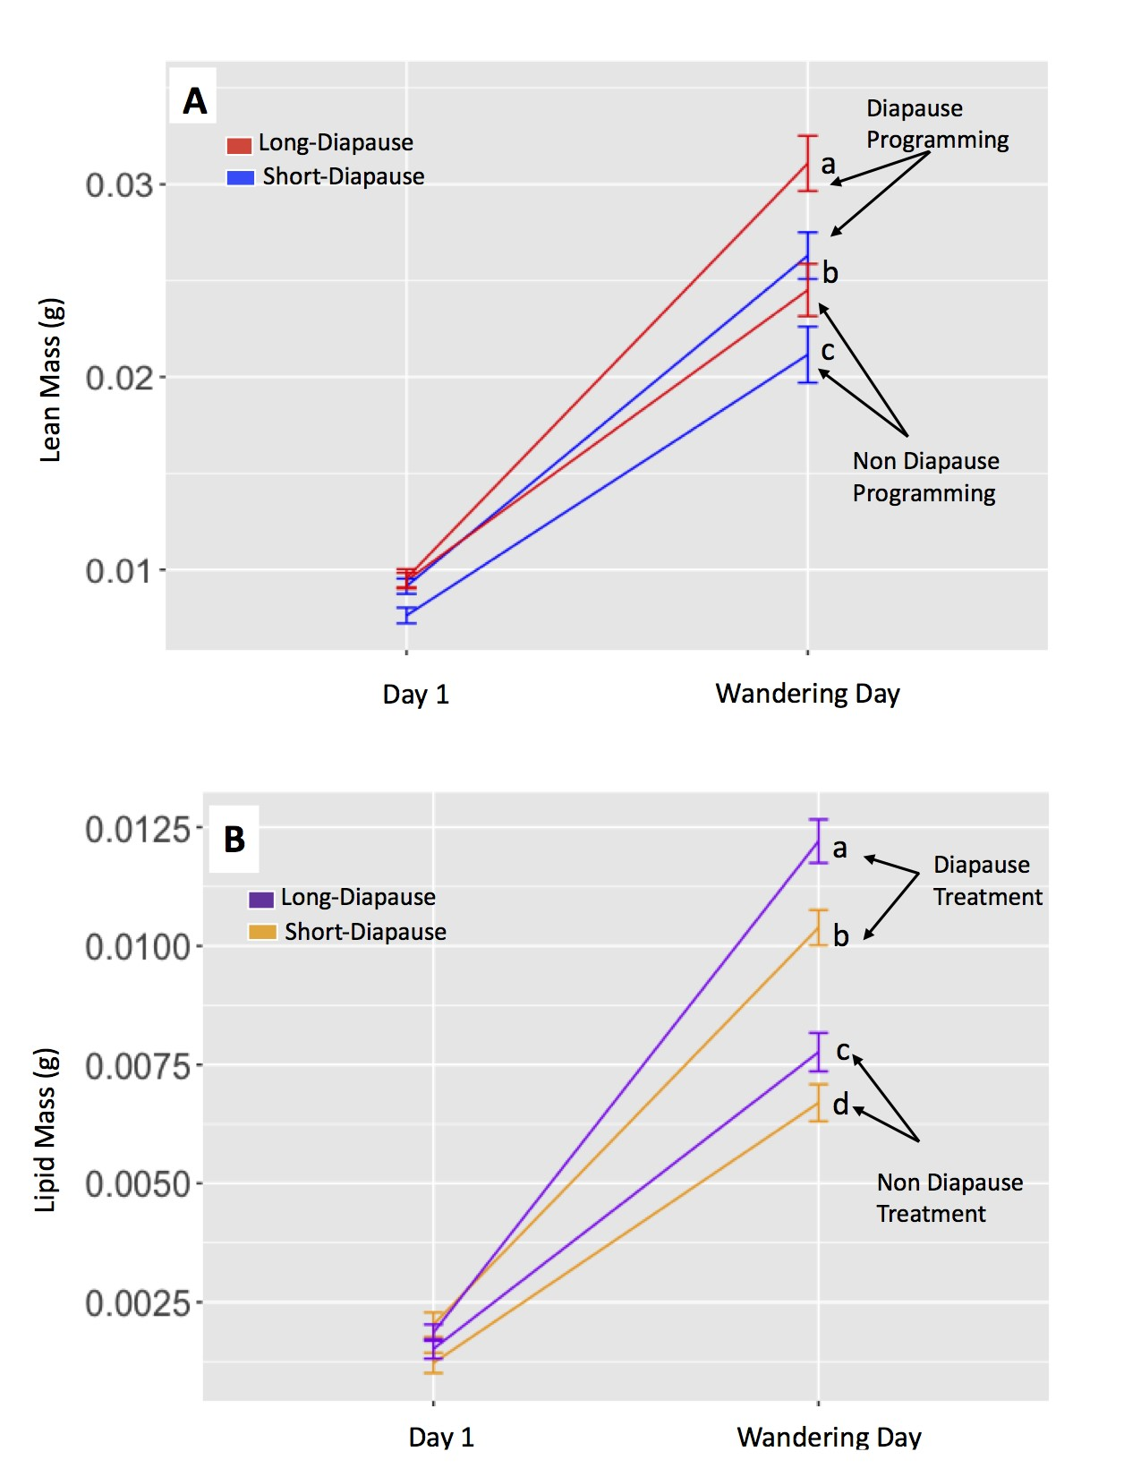

Figure 3-7. Comparing lean mass and lipid mass accumulation prior to the onset of diapause. Lower case letters represent significance. (A) Lean mass accumulation comparison between long-diapause genotype (red) and the short-diapause genotype (blue) individuals prior to the onset of diapause. Lean mass accumulation between individuals reared in diapause programming conditions (a and b) and non-diapause conditions (b and c) was significantly affected by diapause genotype (t-value=6.85, Df=10.9, p-value*<*0.000) and photoperiod (t-value=-9.66, Df=133.3, p-value*<*0.000). (B) Comparing lipid mass accumulation between long-diapause genotype larvae (purple) and short-diapause genotype larvae (orange) prior to the onset of diapause. Lipid mass accumulation between diapause programed individuals (a and b) and individuals in non-diapause conditions (c and d) was significantly affected by diapause genotype (t-value=4.08, Df=186.8, p-value*<*0.000) and photoperiod (t-value=-10.23, Df=191.6, p-value*<*0.000).

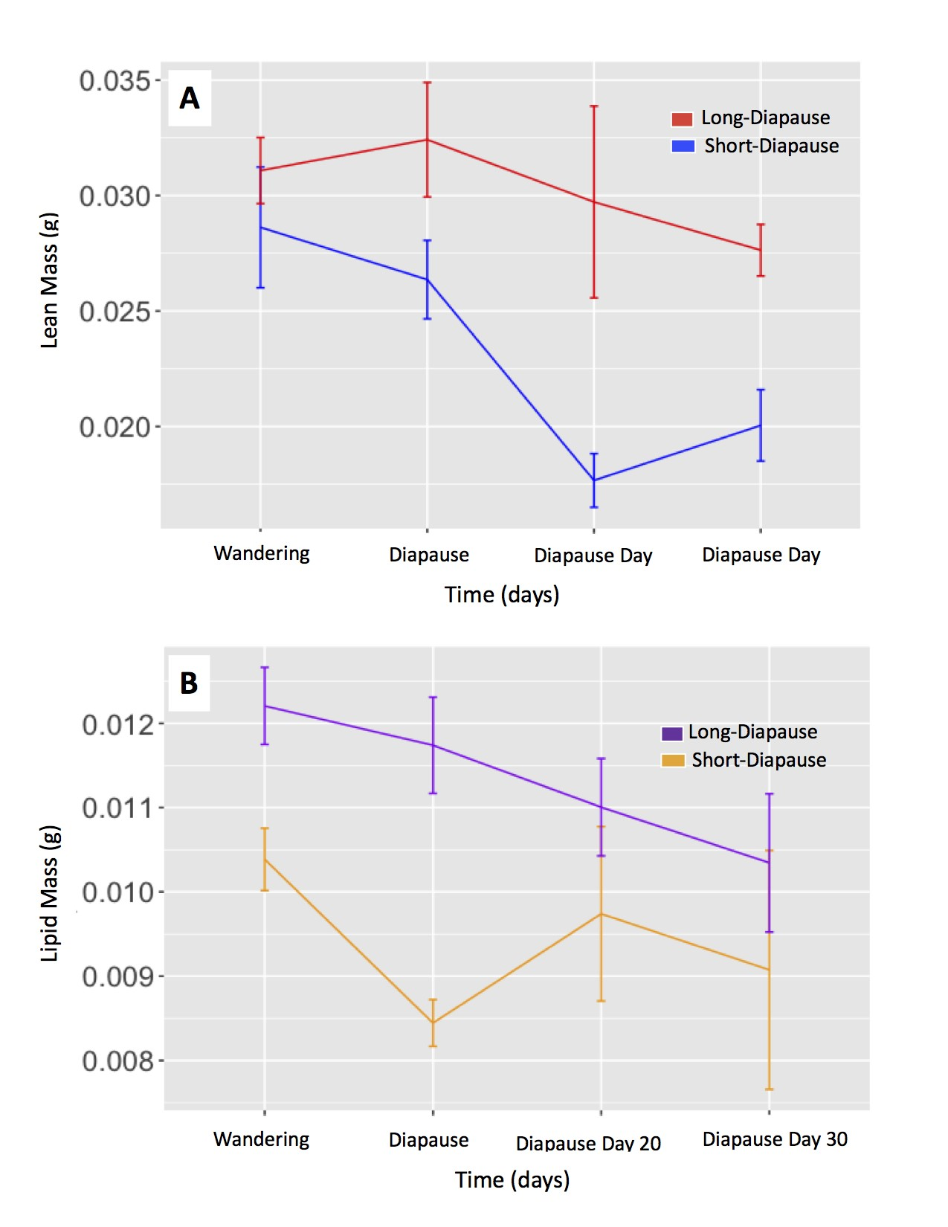

Figure 3-8. Comparing lipid mass depletion and lean mass depletion between individuals reared in diapause programming conditions. (A) Comparing lean mass depletion during diapause between the long-diapause genotype (red) and short-diapause genotype (blue). Lean mass depletion during diapause was significantly different between diapause genotypes (t-value=2.45, Df=10.7, p-value=0.033). Lean mass did not significantly change among larvae within a single diapause genotype during diapause (3-7A,B). (B) Comparing lipid mass depletion between the long-diapause genotype (purple) and the short-diapause genotype (orange). Lipid mass depletion during diapause was significantly affected by diapause genotype (t-value=4.74, Df=16.7, p-value=0.000) and Sample day fifteen significantly affected lipid mass depletion (t-value=-2.38, Df=14.1, p-value=0.032). Lipid mass depletion among long-diapause genotype larvae did not significantly change during diapause (3-9A). Among short-diapause genotype larvae, lipid mass depletion was only significantly different on day 15 (t-value=-3.88, Df=111.4, p-value*<*0.000) (3-9B).

Table 3-1. FULL MODEL: ANOVA summary table for the additive and interactive effects of photoperiod and diapause genotype, and the effect of lean mass on lipid mass accumulation. Asterisks "*" indicate statistical significance, ns represents non-significant results.

|  |  |  |  |
| --- | --- | --- | --- |
| Model | Df | F | P |
| A). Lipid mass accumulation on first day of final larval instar |  |  |  |
| Diapause Genotype | 77.4 | 0.16 | 0.696*ns* |
| Photoperiod | 75.9 | 7.43 | 0.008* |
| Lean Mass | 79.6 | 8.61 | 0.004* |
| Diapause Genotype x Photoperiod | 74.4 | 0.17 | 0.684*ns* |
| B). Lipid mass accumulation on wandering day |  |  |  |
| Diapause Genotype | 186.8 | 16.65 | *<*0.000* |
| Photoperiod | 191.6 | 104.74 | *<*0.000* |
| Lean Mass | 16.3 | 0.01 | 0.927*ns* |
| Diapause Genotype x Photoperiod | 186.2 | 1.46 | 0.228*ns* |

Table 3-2. FULL MODEL: ANOVA summary table for the additive and interactive effects of sample day and diapause genotype, and the effect of lean mass on lipid mass depletion. Asterisks "*" indicate statistical significance, ns represents non-significant results.

|  |  |  |  |
| --- | --- | --- | --- |
| Model | Df | F | P |
| Lipid mass during the first 30-days of diapause |  |  |  |
| Diapause Genotype | 25.3 | 17.50 | 0.000* |
| Sample Day | 20.4 | 63.87 | *<*0.000* |
| Lean Mass | 37.9 | 1.37 | 0.248*ns* |
| Diapause Genotype x Sample Day | 16.1 | 2.05 | 0.135*ns* |

Table 3-3. FULL MODEL: ANOVA summary table for the additive and interactive effects of photoperiod and diapause genotype and the effect on lean mass accumulation.

Asterisks "*" indicate statistical significance, ns represents non-significant results.

|  |  |  |  |
| --- | --- | --- | --- |
| Model | Df | F | P |
| A). Lean mass accumulation on first day of final larval instar |  |  |  |
| Diapause Genotype | 1 | 1.44 | 0.233*ns* |
| Photoperiod | 1 | 1.07 | 0.304*ns* |
| Diapause Genotype x Photoperiod | 1 | 1.52 | 0.221*ns* |
| B). Lean mass accumulation on wandering day |  |  |  |
| Diapause Genotype | 10.9 | 46.86 | 0* |
| Photoperiod | 133.3 | 93.81 | *<*0.000* |
| Diapause Genotype x Photoperiod | 129.7 | 0.12 | 0.734*ns* |

Table 3-4. FULL MODEL: ANOVA summary table for the additive and interactive effects of

sample day and diapause genotype on lean mass depletion. Asterisks "*" indicate statistical significance, ns represents non-significant results.

|  |  |  |  |
| --- | --- | --- | --- |
| Model | Df | F | P |
| Lean mass depletion during the first 30-days of diapause |  |  |  |
| Diapause Genotype | 18.7 | 6.00 | 0.025* |
| Sample Day | 21.2 | 8.77 | *<*0.000* |
| Diapause Genotype x Sample Day | 9.8 | 1.19 | 0.374*ns* |

Table 3-5. Linear models comparing CO2 production between diapause genotypes and photoperiods on the day wet mass peaked.

|  |  |  |  |
| --- | --- | --- | --- |
| Model | Df | t value | P |
| A). CO2 production between individuals in diapause conditions  Diapause Genotype | 26 | -5.51 | *<*0.000* |
| B). CO2 production between individuals in non-diapause conditions  Diapause Genotype | 47 | -3.74 | 0.001* |
| C). CO2 production among long-diapause individuals  Photoperiod | 30 | 4.47 | *<*0.000* |
| D). CO2 production among short-diapause individuals  Photoperiod | 43 | 5.0 | *<*0.000* |
| E). CO2 production between shallow and deep-diapause individuals  Diapause phenotype | 14 | -1.03 | 0.319*ns* |

Table 3-6. Linear models comparing CO2 production between diapause genotypes and photoperiods on wandering day.

|  |  |  |  |
| --- | --- | --- | --- |
| Model | Df | t value | P |
| A). CO2 production among long-diapause individuals  Photoperiod | 46 | 8.12 | *<*0.000* |
| B). CO2 production among short-diapause individuals  Photoperiod | 26 | 9.08 | 0.000* |
| C). CO2 production between individuals in non-diapause conditions  Diapause Genotype | 46 | -0.43 | 0.673*ns* |
| D). CO2 production between individuals in diapause conditions  Diapause Genotype | 26 | 0.91 | 0.369*ns* |
| E). CO2 production between shallow and deep-diapause individuals  Diapause phenotype on Day 9 | 14 | 1.85 | 0.085*ns* |
| F). CO2 production between shallow and deep-diapause individuals  Diapause phenotype on Day 11 | 14 | 0.66 | 0.554*ns* |

Table 3-7. Linear model comparing the onset of wandering day between diapause conditions and between short-diapause and long-diapause genotypes in non-diapause and diapause conditions.

|  |  |  |  |
| --- | --- | --- | --- |
| Model | Df | t value | P |
| A). Wandering day in non-diapause conditions |  |  |  |
| Diapause Genotype | 2 | -0.51 | 0.663*ns* |
| B). Wandering day in diapause conditions |  |  |  |
| Diapause Genotype | 2 | 1.06 | 0.401*ns* |
| C). Wandering day between photoperiod |  |  |  |
| Diapause Genotype | 2 | 1.86 | 0.204*ns* |
| Photoperiod | 3381 | -45.82 | <0.000* |
| Diapause Genotype x Photoperiod | 3380 | -17.54 | <0.000* |

Table 3-8. REDUCED MODEL: Linear mixed effects model table for lipid mass and lean mass accumulation between long-diapause genotype and short-diapause genotype larvae in diapause programming and non-diapause conditions. Asterisks "*" indicate statistical significance, ns represents non-significant.

|  |  |  |  |  |  |  |  |  |
| --- | --- | --- | --- | --- | --- | --- | --- | --- |
| Model | | | Df | | t value | | P | |
| A). Lipid mass on first day of final larval instar | | |  | |  | |  | |
| Lean Mass | | | 79.6 | | 2.93 | | 0.004* | |
| Photoperiod | | | 75.9 | | -2.73 | | 0.008* | |
| B). Lean mass on first day of final larval instar |  | |  | |  | |
| Diapause Genotype | 5.9 | | 2.03 | | 0.089*ns* | |
| Photoperiod | 77.7 | | -1.13 | | 0.261*ns* | |
| C). Lean mass on wandering Day |  | |  | |  | |
| Diapause Genotype | 10.9 | | 6.85 | | *<*0.000* | |
| Photoperiod | 133.3 | | -9.66 | | *<*0.000* | |
| D). Lipid mass on wandering day | | |  | |  | |  | |
| Diapause Genotype | | | 186.8 | | 4.08 | | *<*0.000* | |
| Photoperiod | | | 191.6 | | -10.23 | | *<*0.000* | |

Table 3-9. REDUCED MODEL: Linear mixed effects model for lean mass and lipid mass depletion between long-diapause and short-diapause genotypes during diapause. Asterisks "*" indicate statistical significance, ns represents non-significant.

|  |  |  |  |  |
| --- | --- | --- | --- | --- |
| Model | | Df | t value | P |
| A). Lean mass depletion: Between genotypes | |  |  |  |
| Diapause genotype | | 10.7 | 2.45 | 0.033* |
| Diapause Day 15 | | 16.5 | 0.18 | 0.861*ns* |
| Diapause Day 20 | | 15.2 | -0.56 | 0.586*ns* |
| Diapause Day 30 | | 16.0 | -0.68 | 0.504*ns* |
| B). Lipid mass depletion: Between genotypes | |  | |  |  | |
| Diapause genotype | | 16.7 | | 4.74 | *<*0.000* | |
| Diapause Day 15 | | 14.1 | | -2.38 | 0.031* | |
| Diapause Day 20 | | 15.8 | | -1.09 | 0.294*ns* | |
| Diapause Day 30 | | 15.2 | | -1.53 | 0.148*ns* | |

Table 3-10. REDUCED MODEL: Linear mixed effects model for lipid mass depletion between long-diapause genotype and short-diapause genotype larvae, among long-diapause genotype larvae, and short-diapause genotype larvae during diapause. Asterisks "*" indicate statistical significance, ns represents non-significant.

|  |  |  |  |  |  |  |  |
| --- | --- | --- | --- | --- | --- | --- | --- |
| Model | | Df | | t value | | P | |
| A). Lean mass depletion: Long-diapause genotype |  |  | |  | |
| Diapause Day 15 | 11.7 | 0.18 | | 0.859*ns* | |
| Diapause Day 20 | 9.8 | -0.27 | | 0.792*ns* | |
| Diapause Day 30 | 10.4 | -0.35 | | 0.736*ns* | |
| B). Lean mass depletion: Short-diapause genotype |  |  | |  | |
| Diapause Day 15 | 14.1 | -0.27 | | 0.793*ns* | |
| Diapause Day 20 | 13.6 | -1.10 | | 0.292*ns* | |
| Diapause Day 30 | 25.0 | -1.00 | | 0.328*ns* | |
| C). Lipid mass depletion: Long-diapause genotype | |  | |  | |  | |
| Diapause Day 15 | | 11.9 | | -0.38 | | 0.714*ns* | |
| Diapause Day 20 | | 9.4 | | -0.90 | | 0.389*ns* | |
| Diapause Day 30 | | 9.9 | | -0.74 | | 0.476*ns* | |
| D). Lipid mass depletion: Short-diapause genotype | |  | |  | |  | |
| Diapause Day 15 | | 111.4 | | -3.88 | | *<*0.000* | |
| Diapause Day 20 | | 111.4 | | 0.75 | | 0.454 | |
| Diapause Day 30 | | 111.4 | | -1.01 | | 0.314 | |

REFERENCES

Adkisson, P. L., R. A. Bell, and S. G. Wellso. 1963. Environmental factors controlling the induction of diapause in the pink bollworm, *Pectinophora gossypiella* (Saunders). Journal of Insect Physiology 9:299-310.

Allison, J. D., and R. T. Cardé. 2016. Pheromone Communication in Moths: Evolution, Behavior, and Application. Illustrate edition. University of California Press.

Arrese, E. L., and J. L. Soulages. 2010. Insect fat body: Energy, metabolism, and regulation. Annual Review of Entomology 55:207-225.

Beck, S. D., and J. W. Apple. 1961. Effects of temperature and photoperiod on voltinism of geographical populations of the European corn borer, *Pyrausta nubilalis*. Journal of Economic Entomology 54:550-558.

Bohnenblust, E., and J. Tooker. 2010. European corn borer in field corn. Entomological Notes.

Bradshaw, W. E., and C. M. Holzapfel. 2001. Genetic shift in photoperiodic response correlated with global warming. Proceedings of the National Academy of Sciences 98:14509-14511.

Breed, G. A., S. Stichter, and E. E. Crone. 2012. Climate-driven changes in northeastern US butterfly communities. Nature Climate Change 3:142-145.

Capinera, J. L. 2000. European corn borer scientific name: *Ostrinia nubilalis* (Hübner) (Insecta: Lepidoptera: Pyralidae) (EENY-156). Gainesville: University of Florida Institute of Food and Agricultural Sciences.

Chown, S. L. 2007. Physiological diversity in insects: Ecology and evolutionary contexts. Advances in Insect Physiology 33:50-152.

de Gruyter, W., 1999. Handbook of Zoology. 35. Lepidoptera, Moths and Butterflies Volume 1: Evolution, Systematics, and Biogeography. Pages 80-82 inN. P. Kristensen, editor. Tropical Lepidoptera. 10, Verlag.

DeLucia, E. H., C. L. Casteel, P. D. Nabity, and B. F. O’Neill. 2008. Insects take a bigger bite out of plants in a warmer, higher carbon dioxide world. Proceedings of the National Academy of Sciences 105:1781-1782.

Dopman, E. B., L. Perez, S. M. Bogdanowicz, and R. G. Harrison. 2005. Consequences of reproductive barriers for genealogical discordance in the European corn borer. Proceedings of the National Academy of Sciences 102:14706-14711.

Dugdale, J. 1995. Index of economically important Lepidoptera. Cambridge University Press.

Folch, J., M. Lees, and G. Stanley. 1957. A simple method for the isolation and purification of total lipides from animal tissues. Journal of Biological Chemistry 226:497-509.

Frolov, A. N., D. Bourguet, and S. Ponsard. 2007. Reconsidering the taxonomy of several *Ostrinia* species in the light of reproductive isolation: A tale for Ernst Mayr. Biological Journal of the Linnean Society 91:49-72

Gelman, D. B., and D. K. Hayes. 1982. Methods and markers for synchronizing maturation of fifth-stage larvae and pupae of the European corn borer, *Ostrinia nubilalis*. Annals of the Entomological Society of America 75:485-493.

Gomi, T., M. Nagasaka, T. Fukuda, and H. Hagihara. 2007. Shifting of the life cycle and life-history traits of the fall webworm in relation to climate change. Entomologia Experimentalis et Applicata 125:179-184.

Hahn, D. A., and D. L. Denlinger. 2007. Meeting the energetic demands of insect diapause: Nutrient storage and utilization. Journal of Insect Physiology 53:760-773.

Huey, R. B., and R. D. Stevenson. 1979. Integrating thermal physiology and ecology of ectotherms: A discussion of approaches. Integrative and Comparative Biology 19:357-366.

Hyde, J., M. A. Martin, P. V. Preckel, and C. R. Edwards. 1999. The economics of Bt corn: Valuing protection from the European corn borer. Review of Agricultural Economics 21:442-454.

Ikten, C., S. R. Skoda, T. E. Hunt, J. Molina-Ochoa, and J. E. Foster. 2011. Genetic variation and inheritance of diapause induction in two distinct voltine ecotypes of *Ostrinia nubilalis* (Lepidoptera: Crambidae). Annals of the Entomological Society of America 104:567-575.

IPCC, 2013. Summary for Policymakers. In: Climate Change 2013: The Physical Science Basis. Contribution of Working Group I to the Fifth Assessment Report of the Intergovernmental Panel on Climate Change. Technical report, Intergovernmental Panel on Climate Change, Cambridge.

Kim, C., S. Hoshizaki, Y. Huang, S. Tatsuki, and Y. Ishikawa. 1999. Usefulness of mitochondrial COII gene sequences in examining phylogenetic relationships in the Asian corn borer, *Ostrinia furnacalis*, and allied species (Lepidoptera: Pyralidae). Applied Entomology and Zoology 34:405-412.

Koštál, V. 2006. Eco-physiological phases of insect diapause. Journal of Insect Physiology 52:113-127.

Lassance, J., A. T. Groot, M. A. Liénard, B. Antony, C. Borgwardt, F. Andersson, E. Hedenström, D. G. Heckel, and C. Löfstedt. 2010. Allelic variation in a fatty-acyl reductase gene causes divergence in moth sex pheromones. Nature 466:486-489.

Levy, R. C., G. M. Kozak, C. B. Wadsworth, B. S. Coates, and E. B. Dopman. 2015. Explaining the sawtooth: Latitudinal periodicity in a circadian gene correlates with shifts in generation number. Journal of Evolutionary Biology 28:40-53.

McLeod, D., and S. D. Beck. 1963. Photoperiodic termination of diapause. The biological bulletin 124:84-96.

Mitchell, C. J., and H. Briegel. 1989. Inability of diapausing *Culex pipiens* (Diptera: Culicidae) to use blood for producing lipid reserves for overwinter survival. Journal of Medical Entomology 26:318-326.

Mutuura, A., and E. Munroe. 1970. Taxonomy and distribution of the European corn borer and allied species: genus *Ostrinia* (Lepidoptera: Pyralidae). Memoirs of the Entomological Society of Canada. 102:1-112.

Nechols, J., M. J. Tauber, C. A. Tauber, and S. Masaki, 1999. Adaptations to Hazardous Seasonal.pdf. Chapter adaptation, pages 159-200 *in* Huffaker and Gutierrez, editors. Ecological Entomology. 2 ed.

NOAA National Centers for Environmental Information. 2017. State of the Climate: Global Climate Report for Annual 2016.

Parmesan, C., N. Ryrholm, C. Stefanescu, J. K. Hill, C. D. Thomas, H. Descimon, B. Huntley, L. Kaila, J. Kullberg, T. Tammaru, W. J. Tennent, J. A. Thomas, and M. Warren. 1999. Poleward shifts in geographical ranges of butterfly species associated with regional warming.

Nature 399:579-583.

R Development Core Team. 2016. R: A Language and Environment for Statistical Computing. R Foundation for Statistical Computing Vienna Austria 0:3-900051.

Regier, J. C., C. Mitter, M. A. Solis, J. E. Hayden, B. Landry, M. Nuss, T. J. Simonsen, S. H. Yen, A. Zwick, and M. P. Cummings. 2012. A molecular phylogeny for the pyraloid moths (Lepidoptera: Pyraloidea) and its implications for higher-level classification. Systematic Entomology 37:635-656.

Roelofs, W. L., J. W. Du, X. H. Tang, P. S. Robbins, and C. J. Eckenrode. 1985. Three European corn borer populations in New York based on sex pheromones and voltinism. Journal of Chemical Ecology 11:829-836.

Sakurai, S., M. Kaya, and S. Satake. 1998. Hemolymph ecdysteroid titer and ecdysteroid-dependent developmental events in the last-larval stadium of the silkworm, *Bombyx mori*: Role of low ecdysteroid titer in larval-pupal metamorphosis and a reappraisal of the head critical period. Journal of Insect Physiology 44:867-881.

Saunders, D. S. 1997. Under-sized larvae from short-day adults of the blow fly, *Calliphora vicina*, side-step the diapause programme. Physiological Entomology 22:249-255.

Showers, W. B., H. C. Chiang, A. J. Keaster, R. E. Hill, G. L. Reed, A. N. Sparks, and G. J. Musick. 1975. Ecotypes of the European corn borer in North America. Environmental Entomology 4:753-760.

Sinclair, B. J. 2015. Linking energetics and overwintering in temperate insects. Journal of Thermal Biology 54:5-11.

Solis, M. A. 2007. Phylogenetic studies and modern classification of the Pyraloidea (Lepidoptera). Revista Colombiana de Entomología 33:1-9.

Tauber, C. A., and M. J. Tauber. 1981. Insect seasonal cycles: genetics and evolution. Annual Review of Ecology and Systematics 12:281-308.

Thompson, A. C., and F. M. Davis. 1981. The effect of temperature on the rate of metabolism of lipids and glycogen in diapausing southwestern corn borer, *Diatraea grandiosella*. Comparative Biochemistry and Physiology - Part A: Physiology 70:555-558.

Vukašinović, E. L., D. W. Pond, M. R. Worland, D. Kojić, J. Purać, D. P. Blagojević, and G. Grubor-Lajšić. 2013. Diapause induces changes in the composition and biophysical properties of lipids in larvae of the European corn borer, *Ostrinia nubilalis* (Lepidoptera: Crambidae). Comparative Biochemistry and Physiology Part B: Biochemistry and Molecular Biology 165:219-225.

Wadsworth, C. B., X. Li, and E. B. Dopman. 2015. A recombination suppressor contributes to ecological speciation in *Ostrinia* moths. Heredity 114:593-600.

Wahlberg, N., C. W. Wheat, and C. Peña. 2013. Timing and patterns in the taxonomic diversification of Lepidoptera (butterflies and moths). PLoS ONE 8:80875.

Williams, C. M., K. E. Marshall, H. A. MacMillan, J. D. Dzurisin, J. J. Hellmann, and B. J. Sinclair. 2012. Thermal variability increases the impact of autumnal warming and drives metabolic depression in an overwintering butterfly. PLoS ONE 7:e34470.

Williams, C. M., H. A. Henry, and B. J. Sinclair. 2015. Cold truths: How winter drives responses of terrestrial organisms to climate change. Biological Reviews 90:214-235.

Wipking, W., M. Viebahn, and D. Neumann. 1995. Oxygen consumption, water, lipid and glycogen content of early and late diapause and non-diapause larvae of the burnet moth *Zygaena trifolii*. Journal of Insect Physiology 41:47-56.

BIOGRAPHICAL SKETCH

James Brown, a Florida native, was born in 1984 in Ft. Lauderdale, Florida and grew up in West Palm Beach, Florida. James grew up curious about the biology of the natural world and leading him to pursue a secondary school education in biological science. At the University of Maryland, College Park, James majored in biological sciences with a concentration in Cell Biology and Molecular Genetics. James received his Bachelor of Biological Science in 2010 and began working in the Insect Behavior and Biological Control Unit of the USDA-ARS CMAVE in Gainesville, Florida before starting his master’s degree. James received his master’s degree in entomology at the University of Florida in May 2019, and is expected to pursue a PhD in

Entomology.